Objective
This notebook introduces fertilizers, the FAOSTAT fertilizers-by-nutrient collection.

Method at a glance
The notebook inspects the list-based structure and previews one annual series from the collection.

What you will do
- load fertilizers
- inspect the number of available series
- preview the first keys
- plot one representative series
source(url("https://raw.githubusercontent.com/cefet-rj-dal/tspredit/main/examples/seed.R"))
library(tspredit)
expand_dataset <- function(x) {
url <- attr(x, "url")
if (is.null(url) || !nzchar(url)) x else loadfulldata(x)
}
data(fertilizers)
fertilizers <- expand_dataset(fertilizers)
cat("Dataset: fertilizers\n")
## Dataset: fertilizers
cat("Series available:", length(fertilizers), "\n")
## Series available: 30
head(names(fertilizers))
## [1] "usa_n" "usa_p2o5" "usa_k2o" "china_n" "china_p2o5" "china_k2o"
head(fertilizers[[1]])
## 1961 1962 1963 1964 1965 1966
## 12.96 15.18 16.85 18.34 20.69 23.69
ts.plot(fertilizers[[1]], ylab = "Value", xlab = "Year", main = names(fertilizers)[1])
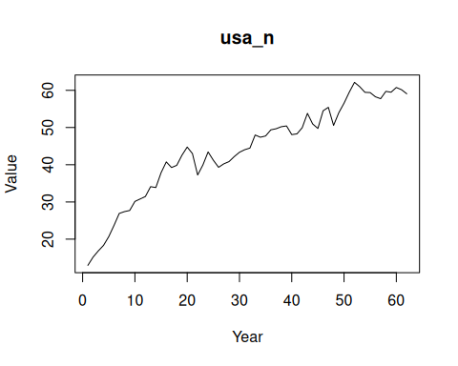

References
- FAOSTAT Fertilizers by Nutrient.

