Objective
This notebook introduces gdp, the GDP and agriculture value-added collection.

Method at a glance
The notebook inspects the list-based structure and previews one annual series from the collection.

What you will do
- load gdp
- inspect the number of available series
- preview the first keys
- plot one representative series
source(url("https://raw.githubusercontent.com/cefet-rj-dal/tspredit/main/examples/seed.R"))
library(tspredit)
expand_dataset <- function(x) {
url <- attr(x, "url")
if (is.null(url) || !nzchar(url)) x else loadfulldata(x)
}
data(gdp)
gdp <- expand_dataset(gdp)
cat("Dataset: gdp\n")
## Dataset: gdp
cat("Series available:", length(gdp), "\n")
## Series available: 10
head(names(gdp))
## [1] "usa_gdp" "china_gdp" "germany_gdp" "japan_gdp" "india_gdp" "uk_gdp"
head(gdp[[1]])
## 1970 1971 1972 1973 1974 1975
## 1073303 1164850 1279110 1425376 1545243 1684904
ts.plot(gdp[[1]], ylab = "Value", xlab = "Year", main = names(gdp)[1])
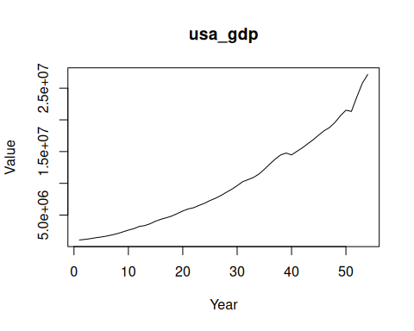

References
- FAOSTAT Macro Indicators Database.

