Objective
This notebook introduces m1, the first Makridakis competition archive.

Method at a glance
The notebook inspects the nested-list structure keyed by frequency and previews one representative series.

What you will do
- load m1
- inspect the available frequency groups
- preview one representative series
- plot a sample series
source(url("https://raw.githubusercontent.com/cefet-rj-dal/tspredit/main/examples/seed.R"))
library(tspredit)
expand_dataset <- function(x) {
url <- attr(x, "url")
if (is.null(url) || !nzchar(url)) x else loadfulldata(x)
}
data(m1)
m1 <- expand_dataset(m1)
cat("Dataset: m1\n")
## Dataset: m1
cat("Frequency groups:", paste(names(m1), collapse = ", "), "\n")
## Frequency groups: monthly, quarterly, yearly
first_group <- names(m1)[1]
first_series <- m1[[first_group]][[1]]
head(first_series)
## [1] 697458.00 4742.66 1656.32 987.63 0.52 15.25
ts.plot(first_series, ylab = "Value", xlab = "Index", main = paste("m1", first_group))
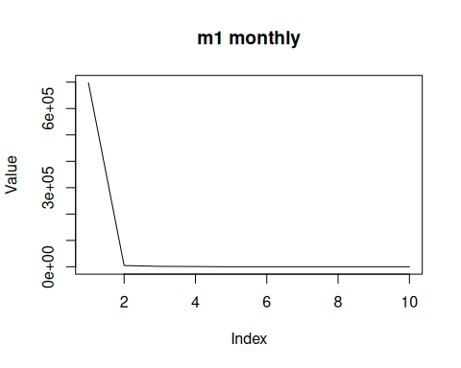

References
- Makridakis et al. (1982). The accuracy of extrapolation methods: Results of a forecasting competition.

