Objective
This notebook introduces m3, the third Makridakis competition archive.

Method at a glance
The notebook inspects the nested-list structure keyed by frequency and previews one representative series.

What you will do
- load m3
- inspect the available frequency groups
- preview one representative series
- plot a sample series
source(url("https://raw.githubusercontent.com/cefet-rj-dal/tspredit/main/examples/seed.R"))
library(tspredit)
expand_dataset <- function(x) {
url <- attr(x, "url")
if (is.null(url) || !nzchar(url)) x else loadfulldata(x)
}
data(m3)
m3 <- expand_dataset(m3)
cat("Dataset: m3\n")
## Dataset: m3
cat("Frequency groups:", paste(names(m3), collapse = ", "), "\n")
## Frequency groups: monthly, other, quarterly, yearly
first_group <- names(m3)[1]
first_name <- names(m3[[first_group]])[1]
first_series <- m3[[first_group]][[first_name]]
head(first_series)
## [1] 2640 2640 2160 4200 3360 2400
ts.plot(first_series, ylab = "Value", xlab = "Index", main = paste("m3", first_group, first_name))
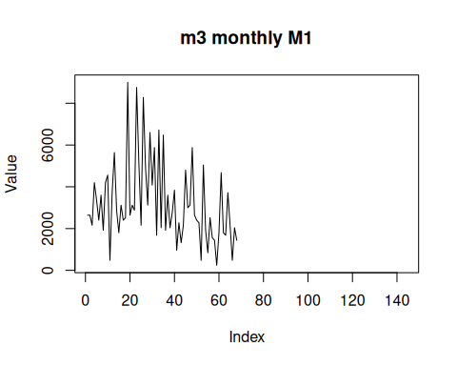

References
- Makridakis and Hibon (2000). The M3-Competition: Results, conclusions and implications.

