Objective
This notebook introduces m4, the fourth Makridakis competition archive.

Method at a glance
The notebook inspects the nested-list structure keyed by frequency and previews one representative series.

What you will do
- load m4
- inspect the available frequency groups
- preview one representative series
- plot a sample series
source(url("https://raw.githubusercontent.com/cefet-rj-dal/tspredit/main/examples/seed.R"))
library(tspredit)
expand_dataset <- function(x) {
url <- attr(x, "url")
if (is.null(url) || !nzchar(url)) x else loadfulldata(x)
}
data(m4)
m4 <- expand_dataset(m4)
cat("Dataset: m4\n")
## Dataset: m4
cat("Frequency groups:", paste(names(m4), collapse = ", "), "\n")
## Frequency groups: hourly, quarterly, weekly, yearly
first_group <- names(m4)[1]
first_name <- names(m4[[first_group]])[1]
first_series <- m4[[first_group]][[first_name]]
head(first_series)
## [1] 605 586 586 559 511 443
ts.plot(first_series, ylab = "Value", xlab = "Index", main = paste("m4", first_group, first_name))
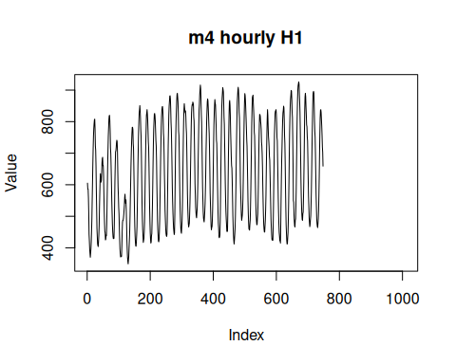

References
- Makridakis et al. (2020). The M4 Competition: Results, findings, conclusion and way forward.

