Objective
This notebook introduces pesticides, the FAOSTAT pesticides-use collection.

Method at a glance
The notebook inspects the list-based structure and previews one annual series from the collection.

What you will do
- load pesticides
- inspect the number of available series
- preview the first keys
- plot one representative series
source(url("https://raw.githubusercontent.com/cefet-rj-dal/tspredit/main/examples/seed.R"))
library(tspredit)
expand_dataset <- function(x) {
url <- attr(x, "url")
if (is.null(url) || !nzchar(url)) x else loadfulldata(x)
}
data(pesticides)
pesticides <- expand_dataset(pesticides)
cat("Dataset: pesticides\n")
## Dataset: pesticides
cat("Series available:", length(pesticides), "\n")
## Series available: 10
head(names(pesticides))
## [1] "india_pesticides" "japan_pesticides" "canada_pesticides" "usa_pesticides" "china_pesticides"
## [6] "germany_pesticides"
head(pesticides[[1]])
## 1990 1991 1992 1993 1994 1995
## 75000 72133 70791 66074 61357 61257
ts.plot(pesticides[[1]], ylab = "Value", xlab = "Year", main = names(pesticides)[1])
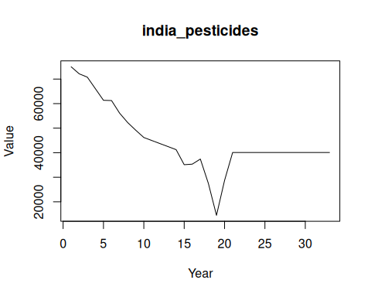

References
- FAOSTAT Pesticides Use Database.

