Objective
This notebook introduces stocks, the packaged B3 stock-market collection.

Method at a glance
The notebook inspects the list-of-data-frames structure and previews one ticker entry with its OHLCV fields.

What you will do
- load stocks
- inspect the available tickers
- preview the structure of the first ticker
- plot the closing-price series
source(url("https://raw.githubusercontent.com/cefet-rj-dal/tspredit/main/examples/seed.R"))
library(tspredit)
expand_dataset <- function(x) {
url <- attr(x, "url")
if (is.null(url) || !nzchar(url)) x else loadfulldata(x)
}
data(stocks)
stocks <- expand_dataset(stocks)
cat("Dataset: stocks\n")
## Dataset: stocks
cat("Tickers available:", length(stocks), "\n")
## Tickers available: 41
head(names(stocks))
## [1] "VALE3" "ITUB4" "PETR4" "PETR3" "BBDC4" "SBSP3"
first_ticker <- names(stocks)[1]
first_series <- stocks[[first_ticker]]
head(first_series)
## date open high low close volume
## 1 2000-01-03 3.500000 3.542500 3.500000 3.500000 585600
## 2 2000-01-04 3.466666 3.474166 3.416666 3.416666 782400
## 3 2000-01-05 3.375000 3.416666 3.375000 3.416666 1876800
## 4 2000-01-06 3.416666 3.500000 3.416666 3.416666 792000
## 5 2000-01-07 3.458333 3.559166 3.458333 3.541666 5347200
## 6 2000-01-10 3.750000 3.833333 3.750000 3.833333 2980800
ts.plot(first_series$close, ylab = "Close", xlab = "Index", main = paste(first_ticker, "close"))
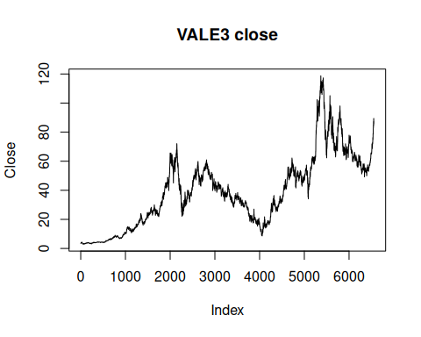

References
- B3 historical trading data.

