Smoothing filter: Applies a default smoothing operator to attenuate high‑frequency components while preserving broader trends. Use as a baseline; for finer control consider dedicated smoothers like LOESS or splines.
Note: - Start with the default settings; if the result under/over-smooths, consider a more tailored filter (e.g., spline with spar, LOWESS with f).
Objectives: This generic smoothing filter reduces short-term variation to reveal the underlying signal. It can be used as a quick denoising step when you do not need a specific smoothing family (e.g., MA, LOWESS, spline).
source(url("https://raw.githubusercontent.com/cefet-rj-dal/tspredit/main/examples/seed.R"))
# Filter - Smooth
# Install tspredit if needed
#install.packages("tspredit")
We load the packages required by this example.
# Load packages
library(daltoolbox)
library(tspredit)
This chunk create a noisy example series.
# Create a noisy example series
data(tsd)
y <- tsd$y
noise <- rnorm(length(y), 0, sd(y)/10)
spike <- rnorm(1, 0, sd(y))
tsd$y <- tsd$y + noise
tsd$y[10] <- tsd$y[10] + spike
tsd$y[20] <- tsd$y[20] + spike
tsd$y[30] <- tsd$y[30] + spike
We plot the data here so the effect of the next transformation can be compared visually.
library(ggplot2)
# Visualize noisy input
plot_ts(x=tsd$x, y=tsd$y) + theme(text = element_text(size=16))
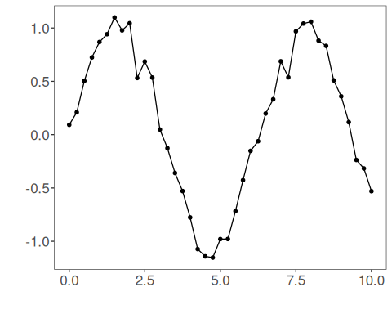
We now apply generic smoothing so its effect on the series can be inspected directly.
# Apply generic smoothing
filter <- ts_fil_smooth() # defaults provide light smoothing
set_example_seed()
filter <- fit(filter, tsd$y)
y <- transform(filter, tsd$y)
# Compare original vs smoothed
plot_ts_pred(y=tsd$y, yadj=y) + theme(text = element_text(size=16))
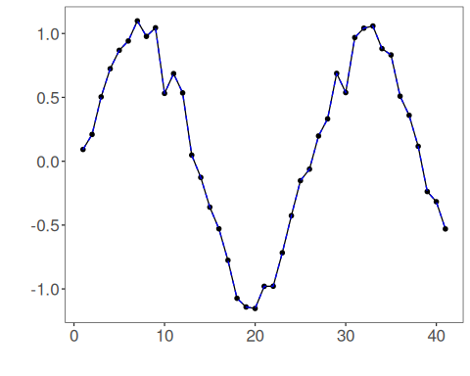
References - T. Hastie, R. Tibshirani, and J. Friedman (2009). The Elements of Statistical Learning. Springer.

