QES Filter: QES extends exponential smoothing by incorporating higher‑order trend components through recursively updated equations. It generalizes single and double exponential smoothing (Holt/Brown) with additional curvature terms to better track accelerating or decelerating trends. Key parameter - gamma: controls whether seasonal/trend gain is adapted (package-specific); set to FALSE to keep default behavior.
Objectives: Quadratic Exponential Smoothing (QES) models level and trend using exponentially weighted averages with a quadratic form. It is useful for trend-dominated series where you want a smooth estimate that adapts to gradual changes.
source(url("https://raw.githubusercontent.com/cefet-rj-dal/tspredit/main/examples/seed.R"))
# Filter - Quadratic Exponential Smoothing
# Install tspredit if needed
#install.packages("tspredit")
We load the packages required by this example.
# Load packages
library(daltoolbox)
library(tspredit)
This chunk prepare a noisy series with injected spikes.
# Prepare a noisy series with injected spikes
data(tsd)
y <- tsd$y
noise <- rnorm(length(y), 0, sd(y)/10)
spike <- rnorm(1, 0, sd(y))
tsd$y <- tsd$y + noise
tsd$y[10] <- tsd$y[10] + spike
tsd$y[20] <- tsd$y[20] + spike
tsd$y[30] <- tsd$y[30] + spike
We plot the data here so the effect of the next transformation can be compared visually.
library(ggplot2)
# Visualize the noisy input
plot_ts(x=tsd$x, y=tsd$y) + theme(text = element_text(size=16))
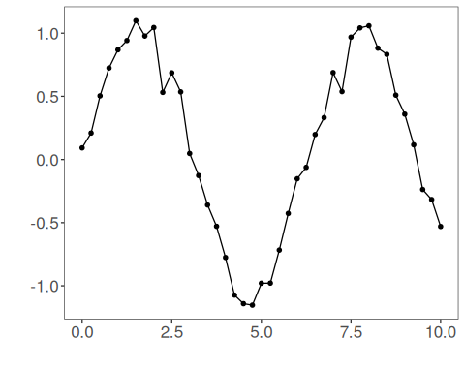
We now apply quadratic exponential smoothing so its effect on the series can be inspected directly.
# Apply Quadratic Exponential Smoothing
filter <- ts_fil_qes(gamma = FALSE) # default behavior without gamma adaptation
set_example_seed()
filter <- fit(filter, tsd$y)
y <- transform(filter, tsd$y)
# Compare original vs smoothed
plot_ts_pred(y=tsd$y, yadj=y) + theme(text = element_text(size=16))
## Warning: Removed 2 rows containing missing values or values outside the scale range (`geom_line()`).
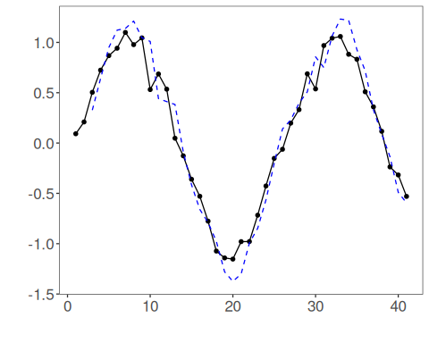
The first fitted points depend on Holt-Winters initialization, so the adjusted series can start with leading NA values while the internal state warms up.
References - E. S. Gardner Jr. (1985). Exponential smoothing: The state of the art. Journal of Forecasting, 4(1), 1–28. - E. S. Gardner Jr. (2006). Exponential smoothing: The state of the art—Part II. International Journal of Forecasting, 22(4), 637–666.

