FFT Filter
About the method - FFT filtering moves the series to the frequency domain, suppresses selected high-frequency components, and reconstructs the signal. - It is useful when noise is better understood as unwanted rapid oscillation rather than isolated spikes.
Didactic goal: connect denoising with frequency analysis instead of only local smoothing.
source(url("https://raw.githubusercontent.com/cefet-rj-dal/tspredit/main/examples/seed.R"))
# Filter - FFT
# Installing the package (if needed)
#install.packages("tspredit")
We start by loading the packages used throughout this example.
# Loading the packages
library(daltoolbox)
library(tspredit)
We build a signal with a smooth low-frequency structure plus a faster oscillatory component. This matches the kind of noise that FFT low-pass filtering is meant to attenuate.
# Series for study with high-frequency oscillatory noise
x <- seq(0, 4 * pi, length.out = 128)
signal <- sin(x)
hf_noise <- 0.25 * sin(12 * x)
y <- signal + hf_noise
Before moving on, we visualize the series so the effect of the next transformation can be compared against the original signal.
# Noisy series visualization
library(ggplot2)
plot_ts(x = x, y = y) + theme(text = element_text(size=16))
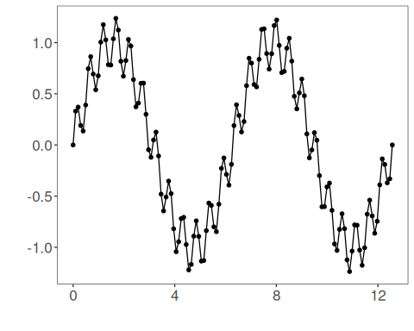
Now we apply the FFT low-pass filter.
# Applying the FFT filter
filter <- ts_fil_fft()
set_example_seed()
filter <- fit(filter, y)
yhat <- transform(filter, y)
plot_ts_pred(x = x, y = y, yadj = yhat) + theme(text = element_text(size=16))
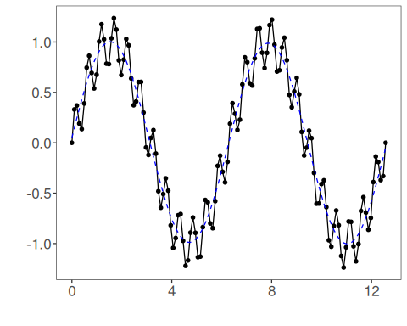
References - A. V. Oppenheim and R. W. Schafer (2010). Discrete-Time Signal Processing. Prentice Hall.

