Wavelet Filter
About the method - Wavelet denoising decomposes the series across multiple scales and removes detail components associated with noise. - It is appropriate when the series contains local patterns at different resolutions.
Didactic goal: understand a multiscale filtering strategy and compare it with FFT-based smoothing.
source(url("https://raw.githubusercontent.com/cefet-rj-dal/tspredit/main/examples/seed.R"))
# Filter - Wavelets
# Installing the package (if needed)
#install.packages("tspredit")
We start by loading the packages used throughout this example.
# Loading the packages
library(daltoolbox)
library(tspredit)
We load the example series that will be used throughout the demonstration.
# Series for study with artificial noise and spikes
data(tsd)
y <- tsd$y
noise <- rnorm(length(y), 0, sd(y)/10)
spike <- rnorm(1, 0, sd(y))
tsd$y <- tsd$y + noise
tsd$y[10] <- tsd$y[10] + spike
tsd$y[20] <- tsd$y[20] + spike
tsd$y[30] <- tsd$y[30] + spike
We plot the data here so the effect of the next transformation can be compared visually.
library(ggplot2)
# Noisy series visualization
plot_ts(x=tsd$x, y=tsd$y) + theme(text = element_text(size=16))
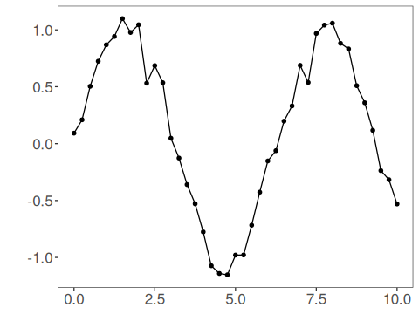
Now we applying the wavelet filter.
# Applying the Wavelet filter
filter <- ts_fil_wavelet()
set_example_seed()
filter <- fit(filter, tsd$y)
y <- transform(filter, tsd$y)
plot_ts_pred(y=tsd$y, yadj=y) + theme(text = element_text(size=16))
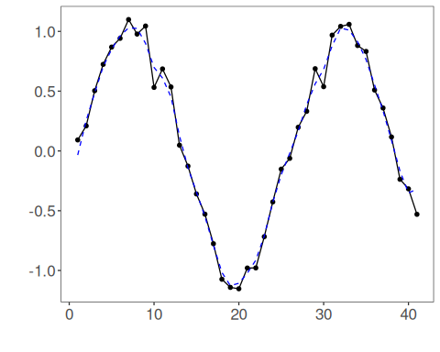
References - D. L. Donoho and I. M. Johnstone (1994). Ideal spatial adaptation by wavelet shrinkage. Biometrika, 81(3), 425–455.

