REMD filter: REMD adopts robustness enhancements to EMD, such as noise‑assisted ensemble strategies (e.g., EEMD/CEEMDAN), to stabilize the decomposition under noise and reduce mode mixing. After decomposition, high‑frequency IMFs are attenuated and the remaining components are summed to form the denoised signal.
When to use: - Nonlinear/nonstationary series where frequency content changes over time - You want a data-driven decomposition without fixed bases (e.g., unlike wavelets/Fourier)
Objectives: Robust Empirical Mode Decomposition (REMD) decomposes a signal into intrinsic mode functions (IMFs) in a way that is less sensitive to noise and outliers than standard EMD. Reconstructing the series from selected IMFs yields a denoised version while preserving nonstationary and nonlinear characteristics.
source(url("https://raw.githubusercontent.com/cefet-rj-dal/tspredit/main/examples/seed.R"))
# Filter - REMD
# Install tspredit if needed
#install.packages("tspredit")
We load the packages required by this example.
# Load packages
library(daltoolbox)
library(tspredit)
This chunk prepare a noisy series with spikes.
# Prepare a noisy series with spikes
data(tsd)
y <- tsd$y
noise <- rnorm(length(y), 0, sd(y)/10)
spike <- rnorm(1, 0, sd(y))
tsd$y <- tsd$y + noise
tsd$y[10] <- tsd$y[10] + spike
tsd$y[20] <- tsd$y[20] + spike
tsd$y[30] <- tsd$y[30] + spike
We plot the data here so the effect of the next transformation can be compared visually.
library(ggplot2)
# Visualize the noisy input
plot_ts(x=tsd$x, y=tsd$y) + theme(text = element_text(size=16))
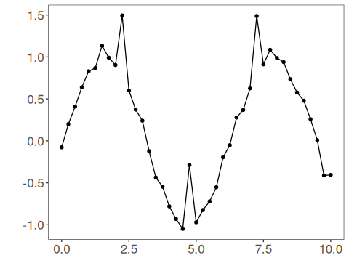
We now apply remd (robust emd) so its effect on the series can be inspected directly.
# Apply REMD (robust EMD)
filter <- ts_fil_remd() # data-driven decomposition into IMFs (robust)
set_example_seed()
filter <- fit(filter, tsd$y)
y <- transform(filter, tsd$y) # reconstruction after robust decomposition
# Compare original vs denoised
plot_ts_pred(y=tsd$y, yadj=y) + theme(text = element_text(size=16))
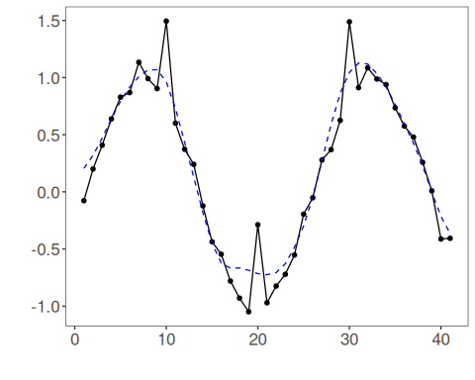
References - Souza, J., et al. REMD: A Novel Hybrid Anomaly Detection Method Based on EMD and ARIMA. IJCNN, 2024. doi:10.1109/IJCNN60899.2024.10651192

