PACF Seasonal Lag Mapping
About the technique - pacf_seasonal starts with seasonal multiples and then completes the set with strong PACF lags. - It is the more selective seasonal hybrid when direct lag effects are preferred over broader autocorrelation echoes.
Didactic goal: combine seasonal structure with a partial-correlation completion rule.
source(url("https://raw.githubusercontent.com/cefet-rj-dal/tspredit/main/examples/seed.R"))
# PACF seasonal lag mapping
library(daltoolbox)
library(tspredit)
data(tsd)
plot_ts(x = tsd$x, y = tsd$y)
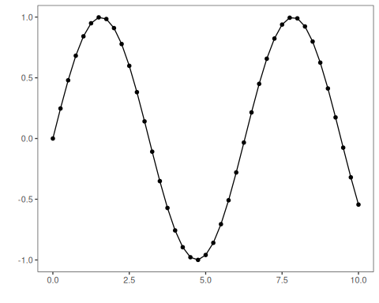
sw_size <- 10
ts <- ts_data(tsd$y, sw_size)
samp <- ts_sample(ts, test_size = 5)
io_train <- ts_projection(samp$train)
io_test <- ts_projection(samp$test)
mapper <- ts_lagmap(method = "pacf_seasonal", seasonality = 4)
mapper <- fit(mapper, io_train$input, io_train$output, input_size = 4)
mapper$lags
## [1] 8 4 2 1
mapper$columns
## [1] "t8" "t4" "t2" "t1"
model <- ts_knn(
preprocess = ts_norm_gminmax(),
input_size = 4,
input_map = ts_lagmap(method = "pacf_seasonal", seasonality = 4),
k = 3
)
set_example_seed()
model <- fit(model, io_train$input, io_train$output)
prediction <- predict(model, io_test$input[1, ], steps_ahead = 5)
evaluate(model, as.vector(io_test$output), as.vector(prediction))
## $values
## [1] 0.41211849 0.17388949 -0.07515112 -0.31951919 -0.54402111
##
## $prediction
## [1] 0.5349524 0.1381953 -0.1059528 -0.3435132 -0.5597157
##
## $smape
## [1] 0.1858229
##
## $mse
## [1] 0.003626603
##
## $R2
## [1] 0.9686768
##
## $metrics
## mse smape R2
## 1 0.003626603 0.1858229 0.9686768

