Lag Mapping Comparison
About the comparison - Different lag selectors emphasize different assumptions about temporal dependence. - This notebook compares the resulting lag subsets on synthetic signals that isolate short-memory, seasonal, and multiscale behavior.
Didactic goal: visualize how the mapping families differ before they are coupled to a predictor.
source(url("https://raw.githubusercontent.com/cefet-rj-dal/tspredit/main/examples/seed.R"))
# Lag mapping comparison
library(daltoolbox)
library(tspredit)
library(ggplot2)
set_example_seed()
n <- 120
x <- 1:n
series_short <- sin(x / 5) + rnorm(n, sd = 0.15)
series_seasonal <- sin(2 * pi * x / 12) + 0.4 * sin(2 * pi * x / 6) + rnorm(n, sd = 0.1)
series_multiscale <- 0.6 * sin(x / 4) + 0.3 * sin(x / 13) + 0.01 * x + rnorm(n, sd = 0.12)
synthetic <- list(
short = series_short,
seasonal = series_seasonal,
multiscale = series_multiscale
)
plot_ts(y = synthetic$short)
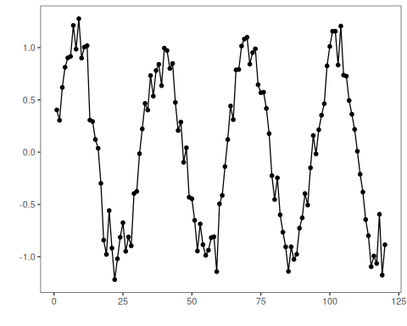
plot_ts(y = synthetic$seasonal)
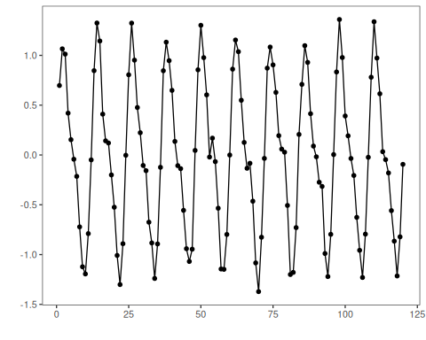
plot_ts(y = synthetic$multiscale)
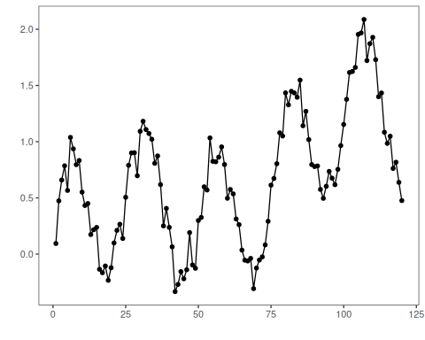
methods <- c("recent", "even", "geom", "acf", "pacf", "seasonal", "mi", "mrmr")
describe_map <- function(series_name, series_values) {
ts <- ts_data(series_values, 13)
io <- ts_projection(ts)
do.call(rbind, lapply(methods, function(method_name) {
mapper <- ts_lagmap(method = method_name, seasonality = 12)
mapper <- fit(mapper, io$input, io$output, input_size = 5)
data.frame(
series = series_name,
method = method_name,
lag = mapper$lags
)
}))
}
mapping_df <- do.call(
rbind,
Map(describe_map, names(synthetic), synthetic)
)
mapping_df
## series method lag
## short.1 short recent 5
## short.2 short recent 4
## short.3 short recent 3
## short.4 short recent 2
## short.5 short recent 1
## short.6 short even 12
## short.7 short even 9
## short.8 short even 7
## short.9 short even 4
## short.10 short even 1
## short.11 short geom 12
## short.12 short geom 6
## short.13 short geom 3
## short.14 short geom 2
## short.15 short geom 1
## short.16 short acf 12
## short.17 short acf 4
## short.18 short acf 3
## short.19 short acf 2
## short.20 short acf 1
## short.21 short pacf 6
## short.22 short pacf 5
## short.23 short pacf 4
## short.24 short pacf 3
## short.25 short pacf 1
## short.26 short seasonal 12
## short.27 short seasonal 4
## short.28 short seasonal 3
## short.29 short seasonal 2
## short.30 short seasonal 1
## short.31 short mi 12
## short.32 short mi 6
## short.33 short mi 3
## short.34 short mi 2
## short.35 short mi 1
## short.36 short mrmr 12
## short.37 short mrmr 10
## short.38 short mrmr 6
## short.39 short mrmr 2
## short.40 short mrmr 1
## seasonal.1 seasonal recent 5
## seasonal.2 seasonal recent 4
## seasonal.3 seasonal recent 3
## seasonal.4 seasonal recent 2
## seasonal.5 seasonal recent 1
## seasonal.6 seasonal even 12
## seasonal.7 seasonal even 9
## seasonal.8 seasonal even 7
## seasonal.9 seasonal even 4
## seasonal.10 seasonal even 1
## seasonal.11 seasonal geom 12
## seasonal.12 seasonal geom 6
## seasonal.13 seasonal geom 3
## seasonal.14 seasonal geom 2
## seasonal.15 seasonal geom 1
## seasonal.16 seasonal acf 12
## seasonal.17 seasonal acf 11
## seasonal.18 seasonal acf 7
## seasonal.19 seasonal acf 6
## seasonal.20 seasonal acf 1
## seasonal.21 seasonal pacf 7
## seasonal.22 seasonal pacf 6
## seasonal.23 seasonal pacf 5
## seasonal.24 seasonal pacf 2
## seasonal.25 seasonal pacf 1
## seasonal.26 seasonal seasonal 12
## seasonal.27 seasonal seasonal 4
## seasonal.28 seasonal seasonal 3
## seasonal.29 seasonal seasonal 2
## seasonal.30 seasonal seasonal 1
## seasonal.31 seasonal mi 12
## seasonal.32 seasonal mi 8
## seasonal.33 seasonal mi 7
## seasonal.34 seasonal mi 5
## seasonal.35 seasonal mi 4
## seasonal.36 seasonal mrmr 12
## seasonal.37 seasonal mrmr 11
## seasonal.38 seasonal mrmr 8
## seasonal.39 seasonal mrmr 7
## seasonal.40 seasonal mrmr 5
## multiscale.1 multiscale recent 5
## multiscale.2 multiscale recent 4
## multiscale.3 multiscale recent 3
## multiscale.4 multiscale recent 2
## multiscale.5 multiscale recent 1
## multiscale.6 multiscale even 12
## multiscale.7 multiscale even 9
## multiscale.8 multiscale even 7
## multiscale.9 multiscale even 4
## multiscale.10 multiscale even 1
## multiscale.11 multiscale geom 12
## multiscale.12 multiscale geom 6
## multiscale.13 multiscale geom 3
## multiscale.14 multiscale geom 2
## multiscale.15 multiscale geom 1
## multiscale.16 multiscale acf 5
## multiscale.17 multiscale acf 4
## multiscale.18 multiscale acf 3
## multiscale.19 multiscale acf 2
## multiscale.20 multiscale acf 1
## multiscale.21 multiscale pacf 11
## multiscale.22 multiscale pacf 6
## multiscale.23 multiscale pacf 5
## multiscale.24 multiscale pacf 4
## multiscale.25 multiscale pacf 1
## multiscale.26 multiscale seasonal 12
## multiscale.27 multiscale seasonal 4
## multiscale.28 multiscale seasonal 3
## multiscale.29 multiscale seasonal 2
## multiscale.30 multiscale seasonal 1
## multiscale.31 multiscale mi 12
## multiscale.32 multiscale mi 4
## multiscale.33 multiscale mi 3
## multiscale.34 multiscale mi 2
## multiscale.35 multiscale mi 1
## multiscale.36 multiscale mrmr 12
## multiscale.37 multiscale mrmr 10
## multiscale.38 multiscale mrmr 5
## multiscale.39 multiscale mrmr 2
## multiscale.40 multiscale mrmr 1
ggplot(mapping_df, aes(x = lag, y = method, color = series)) +
geom_point(size = 3) +
facet_wrap(~series, ncol = 1) +
scale_x_reverse() +
labs(
title = "Lag subsets chosen by different mapping rules",
x = "Lag",
y = "Mapping method"
)
