No Normalization
About the technique
- ts_norm_none() leaves the numerical scale unchanged.
- Its role is to establish whether a predictor already works well on the raw scale before introducing transformations.
Didactic goal: use the raw series as the baseline for judging later normalization strategies.
source(url("https://raw.githubusercontent.com/cefet-rj-dal/tspredit/main/examples/seed.R"))
# No normalization
# Installing the package (if needed)
#install.packages("tspredit")
We start by loading the packages used throughout this example.
library(daltoolbox)
library(tspredit)
library(ggplot2)
We load the example series that will be used throughout the demonstration.
data(tsd)
The first plot shows the original series. This is the common visual reference for all normalization examples in this folder.
plot_ts(x = tsd$x, y = tsd$y) + theme(text = element_text(size = 16))
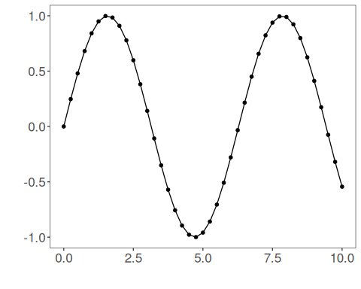
The next step organizes the series into sliding windows, which is the tabular representation used by the later transformations and models.
sw_size <- 10
ts <- ts_data(tsd$y, sw_size)
ts_head(ts, 3)
## t9 t8 t7 t6 t5 t4 t3 t2 t1 t0
## [1,] 0.0000000 0.2474040 0.4794255 0.6816388 0.8414710 0.9489846 0.9974950 0.9839859 0.9092974 0.7780732
## [2,] 0.2474040 0.4794255 0.6816388 0.8414710 0.9489846 0.9974950 0.9839859 0.9092974 0.7780732 0.5984721
## [3,] 0.4794255 0.6816388 0.8414710 0.9489846 0.9974950 0.9839859 0.9092974 0.7780732 0.5984721 0.3816610
summary(ts[, 10])
## t0
## Min. :-0.99929
## 1st Qu.:-0.55091
## Median : 0.05397
## Mean : 0.02988
## 3rd Qu.: 0.63279
## Max. : 0.99460
We now keep the values unchanged and compare the supervised target column (t0) before and after the transformation.
preproc <- ts_norm_none()
set_example_seed()
preproc <- fit(preproc, ts)
tst <- transform(preproc, ts)
ts_head(tst, 3)
## t9 t8 t7 t6 t5 t4 t3 t2 t1 t0
## [1,] 0.0000000 0.2474040 0.4794255 0.6816388 0.8414710 0.9489846 0.9974950 0.9839859 0.9092974 0.7780732
## [2,] 0.2474040 0.4794255 0.6816388 0.8414710 0.9489846 0.9974950 0.9839859 0.9092974 0.7780732 0.5984721
## [3,] 0.4794255 0.6816388 0.8414710 0.9489846 0.9974950 0.9839859 0.9092974 0.7780732 0.5984721 0.3816610
summary(tst[, 10])
## t0
## Min. :-0.99929
## 1st Qu.:-0.55091
## Median : 0.05397
## Mean : 0.02988
## 3rd Qu.: 0.63279
## Max. : 0.99460
compare_t0 <- rbind(
data.frame(idx = seq_len(nrow(ts)), value = as.vector(ts[, ncol(ts)]), series = "original t0"),
data.frame(idx = seq_len(nrow(tst)), value = as.vector(tst[, ncol(tst)]), series = "transformed t0")
)
ggplot(compare_t0, aes(x = idx, y = value, color = series)) +
geom_line(linewidth = 0.7) +
theme_minimal(base_size = 14)
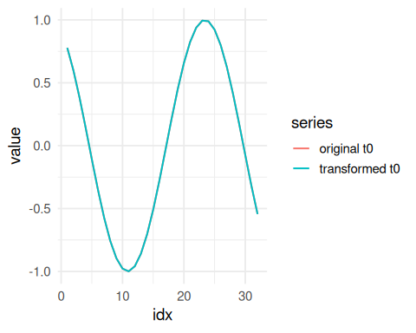
What to observe
- The two curves should overlap completely.
- This file is the baseline reference for the other normalization examples.
References
- C. M. Bishop (2006). Pattern Recognition and Machine Learning. Springer.

