Global Min-Max Normalization
About the technique
- Global min-max normalization rescales the training values to a fixed interval, usually [0, 1].
- It preserves relative ordering while making magnitudes easier for many learning algorithms to handle.
Didactic goal: inspect the simplest global scaling strategy used in forecasting pipelines.
source(url("https://raw.githubusercontent.com/cefet-rj-dal/tspredit/main/examples/seed.R"))
# Global Min-Max Normalization
# Installing the package (if needed)
#install.packages("tspredit")
We start by loading the packages used throughout this example.
library(daltoolbox)
library(tspredit)
library(ggplot2)
We load the example series that will be used throughout the demonstration.
data(tsd)
The first plot shows the original series. This is the common visual reference for all normalization examples in this folder.
plot_ts(x = tsd$x, y = tsd$y) + theme(text = element_text(size = 16))
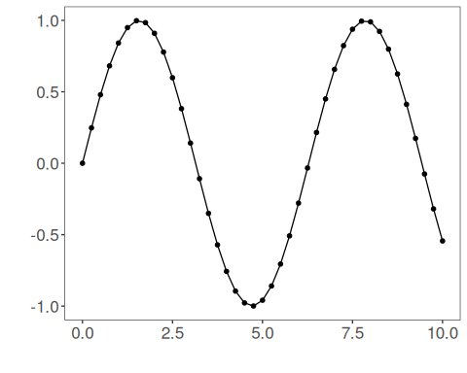
The next step organizes the series into sliding windows, which is the tabular representation used by the later transformations and models.
sw_size <- 10
ts <- ts_data(tsd$y, sw_size)
ts_head(ts, 3)
## t9 t8 t7 t6 t5 t4 t3 t2 t1 t0
## [1,] 0.0000000 0.2474040 0.4794255 0.6816388 0.8414710 0.9489846 0.9974950 0.9839859 0.9092974 0.7780732
## [2,] 0.2474040 0.4794255 0.6816388 0.8414710 0.9489846 0.9974950 0.9839859 0.9092974 0.7780732 0.5984721
## [3,] 0.4794255 0.6816388 0.8414710 0.9489846 0.9974950 0.9839859 0.9092974 0.7780732 0.5984721 0.3816610
summary(ts[, 10])
## t0
## Min. :-0.99929
## 1st Qu.:-0.55091
## Median : 0.05397
## Mean : 0.02988
## 3rd Qu.: 0.63279
## Max. : 0.99460
We now apply global min-max normalization and compare the supervised target column (t0) before and after the transformation.
preproc <- ts_norm_gminmax()
set_example_seed()
preproc <- fit(preproc, ts)
tst <- transform(preproc, ts)
ts_head(tst, 3)
## t9 t8 t7 t6 t5 t4 t3 t2 t1 t0
## [1,] 0.5004502 0.6243512 0.7405486 0.8418178 0.9218625 0.9757058 1.0000000 0.9932346 0.9558303 0.8901126
## [2,] 0.6243512 0.7405486 0.8418178 0.9218625 0.9757058 1.0000000 0.9932346 0.9558303 0.8901126 0.8001676
## [3,] 0.7405486 0.8418178 0.9218625 0.9757058 1.0000000 0.9932346 0.9558303 0.8901126 0.8001676 0.6915877
summary(tst[, 10])
## t0
## Min. :0.0000
## 1st Qu.:0.2246
## Median :0.5275
## Mean :0.5154
## 3rd Qu.:0.8174
## Max. :0.9985
compare_t0 <- rbind(
data.frame(idx = seq_len(nrow(ts)), value = as.vector(ts[, ncol(ts)]), series = "original t0"),
data.frame(idx = seq_len(nrow(tst)), value = as.vector(tst[, ncol(tst)]), series = "transformed t0")
)
ggplot(compare_t0, aes(x = idx, y = value, color = series)) +
geom_line(linewidth = 0.7) +
theme_minimal(base_size = 14)
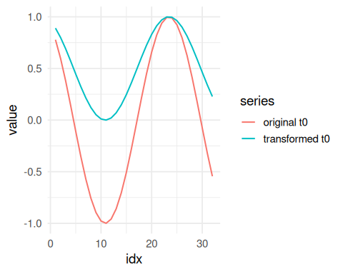
What to observe
- The transformed curve is restricted to a common global interval.
- The ordering of peaks and valleys is preserved, but the original magnitude is removed.
References
- C. M. Bishop (2006). Pattern Recognition and Machine Learning. Springer.

