Sliding-Window Min-Max Normalization
About the technique
- This strategy normalizes each window with its own local minimum and maximum.
- It emphasizes local shape over absolute level, which can help when amplitude varies through time.
Didactic goal: compare local scaling with global scaling and see what information each one keeps or removes.
source(url("https://raw.githubusercontent.com/cefet-rj-dal/tspredit/main/examples/seed.R"))
# Window-based Normalization (Min-Max)
# Installing the package (if needed)
#install.packages("tspredit")
We start by loading the packages used throughout this example.
library(daltoolbox)
library(tspredit)
library(ggplot2)
We load the example series that will be used throughout the demonstration.
data(tsd)
The first plot shows the original series. This is the common visual reference for all normalization examples in this folder.
plot_ts(x = tsd$x, y = tsd$y) + theme(text = element_text(size = 16))
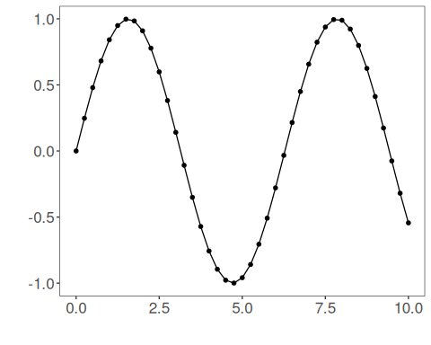
The next step organizes the series into sliding windows, which is the tabular representation used by the later transformations and models.
sw_size <- 10
ts <- ts_data(tsd$y, sw_size)
ts_head(ts, 3)
## t9 t8 t7 t6 t5 t4 t3 t2 t1 t0
## [1,] 0.0000000 0.2474040 0.4794255 0.6816388 0.8414710 0.9489846 0.9974950 0.9839859 0.9092974 0.7780732
## [2,] 0.2474040 0.4794255 0.6816388 0.8414710 0.9489846 0.9974950 0.9839859 0.9092974 0.7780732 0.5984721
## [3,] 0.4794255 0.6816388 0.8414710 0.9489846 0.9974950 0.9839859 0.9092974 0.7780732 0.5984721 0.3816610
summary(ts[, 10])
## t0
## Min. :-0.99929
## 1st Qu.:-0.55091
## Median : 0.05397
## Mean : 0.02988
## 3rd Qu.: 0.63279
## Max. : 0.99460
We now apply sliding-window min-max normalization and compare the supervised target column (t0) before and after the transformation.
preproc <- ts_norm_swminmax()
set_example_seed()
preproc <- fit(preproc, ts)
tst <- transform(preproc, ts)
ts_head(tst, 3)
## t9 t8 t7 t6 t5 t4 t3 t2 t1 t0
## [1,] 0.0000000 0.2480253 0.4806295 0.6833506 0.8435842 0.9513678 1.0000000 0.9864570 0.9115809 0.7800272
## [2,] 0.0000000 0.3093246 0.5789095 0.7919932 0.9353274 1.0000000 0.9819901 0.8824175 0.7074731 0.4680341
## [3,] 0.1587515 0.4871082 0.7466460 0.9212282 1.0000000 0.9780638 0.8567835 0.6436998 0.3520610 0.0000000
summary(tst[, 10])
## t0
## Min. :0.0000
## 1st Qu.:0.0000
## Median :0.2264
## Mean :0.4301
## 3rd Qu.:0.9974
## Max. :1.0000
compare_t0 <- rbind(
data.frame(idx = seq_len(nrow(ts)), value = as.vector(ts[, ncol(ts)]), series = "original t0"),
data.frame(idx = seq_len(nrow(tst)), value = as.vector(tst[, ncol(tst)]), series = "transformed t0")
)
ggplot(compare_t0, aes(x = idx, y = value, color = series)) +
geom_line(linewidth = 0.7) +
theme_minimal(base_size = 14)
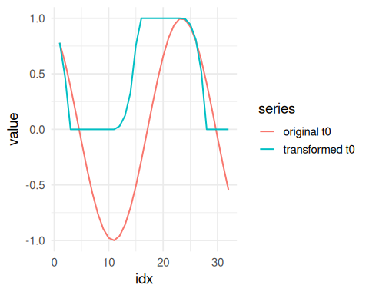
What to observe
- The transformed curve reacts to each local window rather than to one global scale.
- Compared with global min-max, this makes local patterns more comparable but removes more absolute-level information.
References
- C. M. Bishop (2006). Pattern Recognition and Machine Learning. Springer.

