Adaptive Divisive Normalization
About the technique - Divisive adaptive normalization rescales each window by its own adaptive reference level. - It is useful when the same local pattern appears at different amplitudes and should be seen as similar by the predictor. - Within the adaptive-normalization family implemented by ts_norm_an(), this is the default operator: operation = "divide".
Didactic goal: understand adaptive normalization as a relative-scale transformation that tracks level drift over time.
source(url("https://raw.githubusercontent.com/cefet-rj-dal/tspredit/main/examples/seed.R"))
# Adaptive Divisive Normalization
# Installing the package (if needed)
#install.packages("tspredit")
We start by loading the packages used throughout this example.
# Loading the packages
library(daltoolbox)
library(tspredit)
We load the example series that will be used throughout the demonstration.
# Series for study
data(tsd)
Before moving on, we visualize the series so the effect of the next transformation can be compared against the original signal.
# Series visualization
library(ggplot2)
plot_ts(x=tsd$x, y=tsd$y) + theme(text = element_text(size=16))
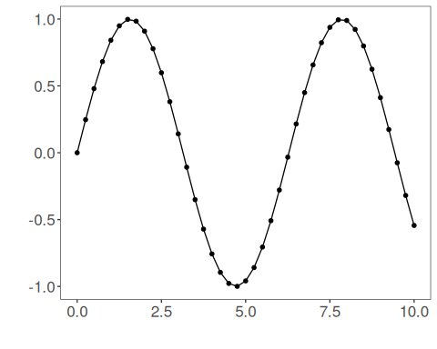
The next step organizes the series into sliding windows, which is the tabular representation used by the later transformations and models.
# Sliding windows
sw_size <- 10
ts <- ts_data(tsd$y, sw_size)
ts_head(ts, 3)
## t9 t8 t7 t6 t5 t4 t3 t2 t1 t0
## [1,] 0.0000000 0.2474040 0.4794255 0.6816388 0.8414710 0.9489846 0.9974950 0.9839859 0.9092974 0.7780732
## [2,] 0.2474040 0.4794255 0.6816388 0.8414710 0.9489846 0.9974950 0.9839859 0.9092974 0.7780732 0.5984721
## [3,] 0.4794255 0.6816388 0.8414710 0.9489846 0.9974950 0.9839859 0.9092974 0.7780732 0.5984721 0.3816610
summary(ts[,10])
## t0
## Min. :-0.99929
## 1st Qu.:-0.55091
## Median : 0.05397
## Mean : 0.02988
## 3rd Qu.: 0.63279
## Max. : 0.99460
This plot isolates the target column so it is easier to understand what the model will ultimately try to predict.
# Target (t0) visualization after windowing
library(ggplot2)
plot_ts(y=ts[,10]) + theme(text = element_text(size=16))
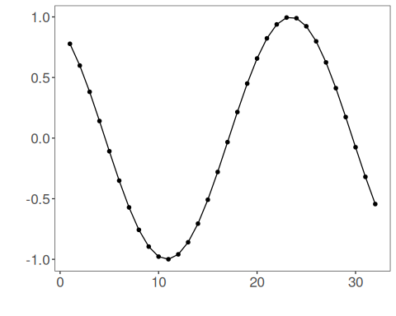
We now apply the divisive version of adaptive normalization.
# Divisive adaptive normalization
preproc <- ts_norm_an()
set_example_seed()
preproc <- fit(preproc, ts)
tst <- transform(preproc, ts)
ts_head(tst, 3)
## t9 t8 t7 t6 t5 t4 t3 t2 t1 t0
## [1,] 0.4104005 0.4703532 0.5265782 0.5755799 0.6143115 0.6403650 0.6521203 0.6488467 0.6307477 0.5989485
## [2,] 0.4655475 0.5172657 0.5623396 0.5979666 0.6219317 0.6327448 0.6297336 0.6130853 0.5838351 0.5438015
## [3,] 0.5153781 0.5596557 0.5946534 0.6181952 0.6288172 0.6258592 0.6095050 0.5807715 0.5414451 0.4939710
summary(tst[,10])
## t0
## Min. :-11.3835
## 1st Qu.: 0.3097
## Median : 0.4831
## Mean : 0.1555
## 3rd Qu.: 0.6143
## Max. : 2.6473
plot_ts(y=ts[1,]) + theme(text = element_text(size=16))
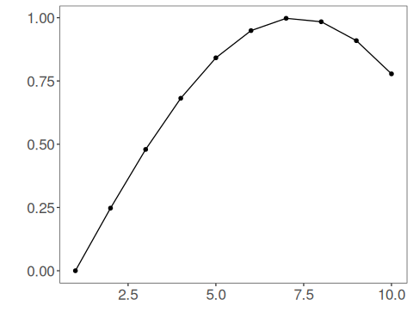
This operator emphasizes relative deviations from the adaptive mean. It is the natural choice when shape invariance across different local scales matters more than preserving additive offsets.
References - Ogasawara, E., Martinez, L. C., De Oliveira, D., Zimbrão, G., Pappa, G. L., Mattoso, M. (2010). Adaptive Normalization: A novel data normalization approach for non-stationary time series. Proceedings of the International Joint Conference on Neural Networks (IJCNN). doi:10.1109/IJCNN.2010.5596746

