Differencing Normalization
About the technique
- Differencing replaces each value by its change relative to the previous observation.
- This reduces trend effects and often makes the series easier to scale and model.
Didactic goal: see how stabilization by differencing changes both the level and the interpretation of the series.
source(url("https://raw.githubusercontent.com/cefet-rj-dal/tspredit/main/examples/seed.R"))
# Normalization by Differences (Diff)
# Installing the package (if needed)
#install.packages("tspredit")
We start by loading the packages used throughout this example.
library(daltoolbox)
library(tspredit)
library(ggplot2)
We load the example series that will be used throughout the demonstration.
data(tsd)
The first plot shows the original series. This is the common visual reference for all normalization examples in this folder.
plot_ts(x = tsd$x, y = tsd$y) + theme(text = element_text(size = 16))
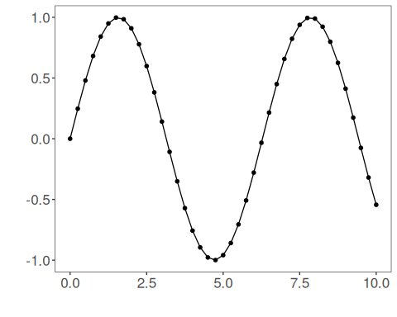
The next step organizes the series into sliding windows, which is the tabular representation used by the later transformations and models.
sw_size <- 10
ts <- ts_data(tsd$y, sw_size)
ts_head(ts, 3)
## t9 t8 t7 t6 t5 t4 t3 t2 t1 t0
## [1,] 0.0000000 0.2474040 0.4794255 0.6816388 0.8414710 0.9489846 0.9974950 0.9839859 0.9092974 0.7780732
## [2,] 0.2474040 0.4794255 0.6816388 0.8414710 0.9489846 0.9974950 0.9839859 0.9092974 0.7780732 0.5984721
## [3,] 0.4794255 0.6816388 0.8414710 0.9489846 0.9974950 0.9839859 0.9092974 0.7780732 0.5984721 0.3816610
summary(ts[, 10])
## t0
## Min. :-0.99929
## 1st Qu.:-0.55091
## Median : 0.05397
## Mean : 0.02988
## 3rd Qu.: 0.63279
## Max. : 0.99460
We now apply differencing-based normalization and compare the supervised target column (t0) before and after the transformation.
preproc <- ts_norm_diff()
set_example_seed()
preproc <- fit(preproc, ts)
tst <- transform(preproc, ts)
ts_head(tst, 3)
## t8 t7 t6 t5 t4 t3 t2 t1 t0
## [1,] 0.9982009 0.9672887 0.9073861 0.8222178 0.7170790 0.5985067 0.4738732 0.3509276 0.23731412
## [2,] 0.9672887 0.9073861 0.8222178 0.7170790 0.5985067 0.4738732 0.3509276 0.2373141 0.14009662
## [3,] 0.9073861 0.8222178 0.7170790 0.5985067 0.4738732 0.3509276 0.2373141 0.1400966 0.06531964
summary(tst[, 9])
## t0
## Min. :0.00000
## 1st Qu.:0.06333
## Median :0.29337
## Mean :0.40975
## 3rd Qu.:0.75129
## Max. :1.00000
compare_t0 <- rbind(
data.frame(idx = seq_len(nrow(ts)), value = as.vector(ts[, ncol(ts)]), series = "original t0"),
data.frame(idx = seq_len(nrow(tst)), value = as.vector(tst[, ncol(tst)]), series = "transformed t0")
)
ggplot(compare_t0, aes(x = idx, y = value, color = series)) +
geom_line(linewidth = 0.7) +
theme_minimal(base_size = 14)
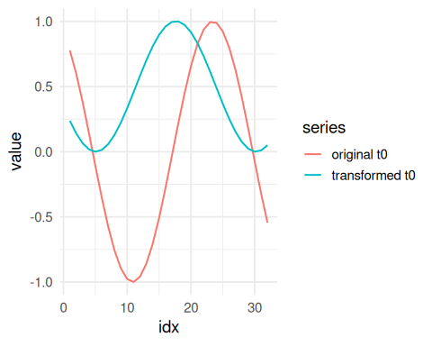
What to observe
- The transformed target now represents local variation rather than absolute level.
- This is useful when trend reduction matters more than preserving the original scale.
References
- G. E. P. Box, G. M. Jenkins, G. C. Reinsel, and G. M. Ljung (2015). Time Series Analysis: Forecasting and Control. Wiley.

