Adaptive Divisive Normalization
About the technique
- Divisive adaptive normalization rescales each window by its own adaptive reference level.
- It is useful when the same local pattern appears at different amplitudes and should be seen as similar by the predictor.
- Within the adaptive-normalization family implemented by ts_norm_an(), this is the default operator: operation = "divide".
Didactic goal: understand adaptive normalization as a relative-scale transformation that tracks level drift over time.
source(url("https://raw.githubusercontent.com/cefet-rj-dal/tspredit/main/examples/seed.R"))
# Adaptive Divisive Normalization
# Installing the package (if needed)
#install.packages("tspredit")
We start by loading the packages used throughout this example.
library(daltoolbox)
library(tspredit)
library(ggplot2)
We load the example series that will be used throughout the demonstration.
data(tsd)
The first plot shows the original series. This is the common visual reference for all normalization examples in this folder.
plot_ts(x = tsd$x, y = tsd$y) + theme(text = element_text(size = 16))
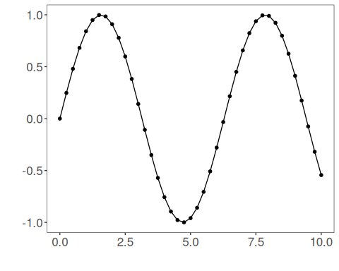
The next step organizes the series into sliding windows, which is the tabular representation used by the later transformations and models.
sw_size <- 10
ts <- ts_data(tsd$y, sw_size)
ts_head(ts, 3)
## t9 t8 t7 t6 t5 t4 t3 t2 t1 t0
## [1,] 0.0000000 0.2474040 0.4794255 0.6816388 0.8414710 0.9489846 0.9974950 0.9839859 0.9092974 0.7780732
## [2,] 0.2474040 0.4794255 0.6816388 0.8414710 0.9489846 0.9974950 0.9839859 0.9092974 0.7780732 0.5984721
## [3,] 0.4794255 0.6816388 0.8414710 0.9489846 0.9974950 0.9839859 0.9092974 0.7780732 0.5984721 0.3816610
summary(ts[, 10])
## t0
## Min. :-0.99929
## 1st Qu.:-0.55091
## Median : 0.05397
## Mean : 0.02988
## 3rd Qu.: 0.63279
## Max. : 0.99460
We now apply the divisive version of adaptive normalization and compare the supervised target column (t0) before and after the transformation.
preproc <- ts_norm_an()
set_example_seed()
preproc <- fit(preproc, ts)
tst <- transform(preproc, ts)
ts_head(tst, 3)
## t9 t8 t7 t6 t5 t4 t3 t2 t1 t0
## [1,] 0.4104005 0.4703532 0.5265782 0.5755799 0.6143115 0.6403650 0.6521203 0.6488467 0.6307477 0.5989485
## [2,] 0.4655475 0.5172657 0.5623396 0.5979666 0.6219317 0.6327448 0.6297336 0.6130853 0.5838351 0.5438015
## [3,] 0.5153781 0.5596557 0.5946534 0.6181952 0.6288172 0.6258592 0.6095050 0.5807715 0.5414451 0.4939710
summary(tst[, 10])
## t0
## Min. :-11.3835
## 1st Qu.: 0.3097
## Median : 0.4831
## Mean : 0.1555
## 3rd Qu.: 0.6143
## Max. : 2.6473
compare_t0 <- rbind(
data.frame(idx = seq_len(nrow(ts)), value = as.vector(ts[, ncol(ts)]), series = "original t0"),
data.frame(idx = seq_len(nrow(tst)), value = as.vector(tst[, ncol(tst)]), series = "transformed t0")
)
ggplot(compare_t0, aes(x = idx, y = value, color = series)) +
geom_line(linewidth = 0.7) +
theme_minimal(base_size = 14)
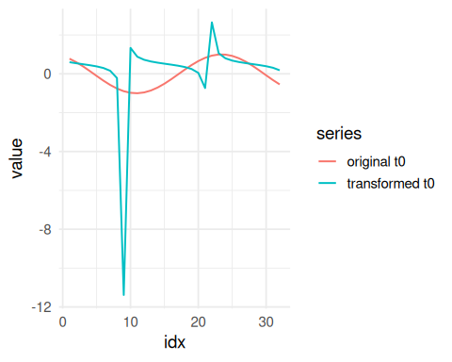
What to observe
- The transformed target emphasizes relative deviations from the adaptive local level.
- This is the most direct adaptive alternative when scale invariance matters more than additive offsets.
References
- Ogasawara, E., Martinez, L. C., De Oliveira, D., Zimbrão, G., Pappa, G. L., Mattoso, M. (2010). Adaptive Normalization: A novel data normalization approach for non-stationary time series. Proceedings of the International Joint Conference on Neural Networks (IJCNN). doi:10.1109/IJCNN.2010.5596746

