Adaptive Subtractive Normalization
About the technique - Subtractive adaptive normalization removes the adaptive local level from each window. - It is useful when the relevant signal is a deviation around a moving baseline, especially near zero where divisive normalization can become unstable. - Within the adaptive-normalization family implemented by ts_norm_an(), this corresponds to operation = "subtract".
Didactic goal: see adaptive normalization as a local detrending operator that preserves additive contrasts.
source(url("https://raw.githubusercontent.com/cefet-rj-dal/tspredit/main/examples/seed.R"))
# Adaptive Subtractive Normalization
# Installing the package (if needed)
#install.packages("tspredit")
We start by loading the packages used throughout this example.
# Loading the packages
library(daltoolbox)
library(tspredit)
We load the example series that will be used throughout the demonstration.
# Series for study
data(tsd)
Before moving on, we visualize the series so the effect of the next transformation can be compared against the original signal.
# Series visualization
library(ggplot2)
plot_ts(x = tsd$x, y = tsd$y) + theme(text = element_text(size = 16))
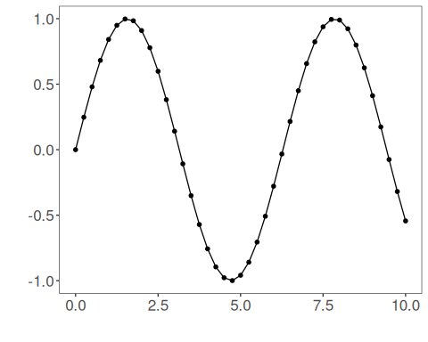
The next step organizes the series into sliding windows, which is the tabular representation used by the later transformations and models.
# Sliding windows
sw_size <- 10
ts <- ts_data(tsd$y, sw_size)
ts_head(ts, 3)
## t9 t8 t7 t6 t5 t4 t3 t2 t1 t0
## [1,] 0.0000000 0.2474040 0.4794255 0.6816388 0.8414710 0.9489846 0.9974950 0.9839859 0.9092974 0.7780732
## [2,] 0.2474040 0.4794255 0.6816388 0.8414710 0.9489846 0.9974950 0.9839859 0.9092974 0.7780732 0.5984721
## [3,] 0.4794255 0.6816388 0.8414710 0.9489846 0.9974950 0.9839859 0.9092974 0.7780732 0.5984721 0.3816610
summary(ts[,10])
## t0
## Min. :-0.99929
## 1st Qu.:-0.55091
## Median : 0.05397
## Mean : 0.02988
## 3rd Qu.: 0.63279
## Max. : 0.99460
This plot isolates the target column so it is easier to understand what the model will ultimately try to predict.
# Target (t0) visualization after windowing
plot_ts(y = ts[,10]) + theme(text = element_text(size = 16))
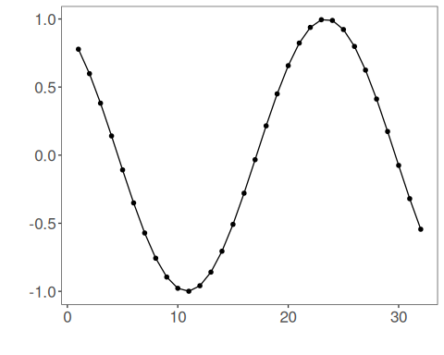
We now apply the subtractive version of adaptive normalization.
# Subtractive adaptive normalization
preproc <- ts_norm_an(operation = "subtract")
set_example_seed()
preproc <- fit(preproc, ts)
tst <- transform(preproc, ts)
ts_head(tst, 3)
## t9 t8 t7 t6 t5 t4 t3 t2 t1 t0
## [1,] 0.1770086 0.2931936 0.4021548 0.4971174 0.5721773 0.6226675 0.6454487 0.6391047 0.6040297 0.5424046
## [2,] 0.2650884 0.3740495 0.4690122 0.5440720 0.5945622 0.6173435 0.6109994 0.5759245 0.5142994 0.4299558
## [3,] 0.3677446 0.4627073 0.5377671 0.5882573 0.6110386 0.6046945 0.5696195 0.5079945 0.4236508 0.3218327
summary(tst[,10])
## t0
## Min. :0.04995
## 1st Qu.:0.15185
## Median :0.41183
## Mean :0.44854
## 3rd Qu.:0.73197
## Max. :0.94995
plot_ts(y = ts[1,]) + theme(text = element_text(size = 16))
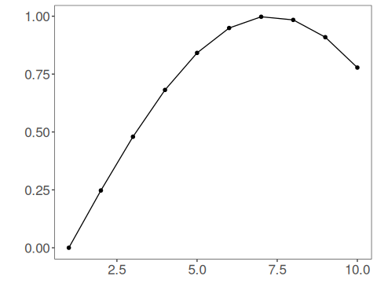
This operator behaves like a moving-baseline differencing rule. It is particularly useful when the local reference level approaches zero and a relative ratio would become unstable or visually misleading.
References - Ogasawara, E., Martinez, L. C., De Oliveira, D., Zimbrão, G., Pappa, G. L., Mattoso, M. (2010). Adaptive Normalization: A novel data normalization approach for non-stationary time series. Proceedings of the International Joint Conference on Neural Networks (IJCNN). doi:10.1109/IJCNN.2010.5596746

