Exponential Adaptive Normalization: EAN computes exponentially weighted means and (optionally) variances within each window using a decay factor. Each window is then centered and scaled by these adaptive statistics, enabling fast adaptation to local changes while smoothing out transient noise.
Key parameter - nw: the effective window span for the exponential averages; smaller values adapt faster to recent changes.
Objectives: EAN rescales each sliding window using exponentially weighted statistics so that the model focuses on shape rather than absolute level. This is helpful when the series level drifts over time (non-stationary mean/variance).
source(url("https://raw.githubusercontent.com/cefet-rj-dal/tspredit/main/examples/seed.R"))
# Exponential Adaptive Normalization
# Install tspredit if needed
#install.packages("tspredit")
We load the packages required by this example.
# Load packages
library(daltoolbox)
library(tspredit)
We load a sample series that will be reused throughout the example.
# Load a sample series
data(tsd)
We plot the data here so the effect of the next transformation can be compared visually.
library(ggplot2)
# Visualize original series
plot_ts(x=tsd$x, y=tsd$y) + theme(text = element_text(size=16))
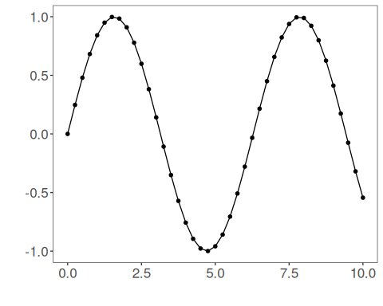
The next step organizes the series into sliding windows, which is the tabular representation used by the later transformations and models.
# Build sliding windows for supervised learning
sw_size <- 10
ts <- ts_data(tsd$y, sw_size)
ts_head(ts, 3)
## t9 t8 t7 t6 t5 t4 t3 t2 t1 t0
## [1,] 0.0000000 0.2474040 0.4794255 0.6816388 0.8414710 0.9489846 0.9974950 0.9839859 0.9092974 0.7780732
## [2,] 0.2474040 0.4794255 0.6816388 0.8414710 0.9489846 0.9974950 0.9839859 0.9092974 0.7780732 0.5984721
## [3,] 0.4794255 0.6816388 0.8414710 0.9489846 0.9974950 0.9839859 0.9092974 0.7780732 0.5984721 0.3816610
summary(ts[,10])
## t0
## Min. :-0.99929
## 1st Qu.:-0.55091
## Median : 0.05397
## Mean : 0.02988
## 3rd Qu.: 0.63279
## Max. : 0.99460
We plot the data here so the effect of the next transformation can be compared visually.
library(ggplot2)
# Visualize the target column (t0) after windowing
plot_ts(y=ts[,10]) + theme(text = element_text(size=16))
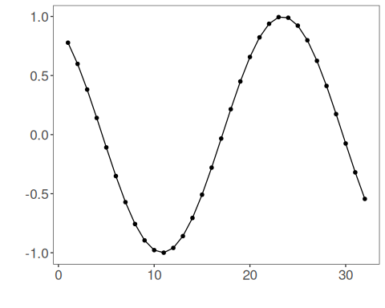
We now apply exponential adaptive normalization so its effect on the series can be inspected directly.
# Apply Exponential Adaptive Normalization
preproc <- ts_norm_ean(nw = 3) # faster adaptation with smaller nw
set_example_seed()
preproc <- fit(preproc, ts)
tst <- transform(preproc, ts)
ts_head(tst, 3)
## t9 t8 t7 t6 t5 t4 t3 t2 t1 t0
## [1,] 0.2323665 0.3104452 0.3836695 0.4474864 0.4979282 0.5318587 0.5471682 0.5429048 0.5193337 0.4779203
## [2,] 0.3580339 0.4312581 0.4950750 0.5455169 0.5794473 0.5947568 0.5904935 0.5669224 0.5255090 0.4688283
## [3,] 0.4924682 0.5562851 0.6067269 0.6406574 0.6559669 0.6517035 0.6281324 0.5867191 0.5300384 0.4616144
summary(tst[,10])
## t0
## Min. :0.4545
## 1st Qu.:0.4608
## Median :0.4804
## Mean :0.4911
## 3rd Qu.:0.5226
## Max. :0.5437
# Inspect one normalized window (shape emphasized)
plot_ts(y=ts[1,]) + theme(text = element_text(size=16))
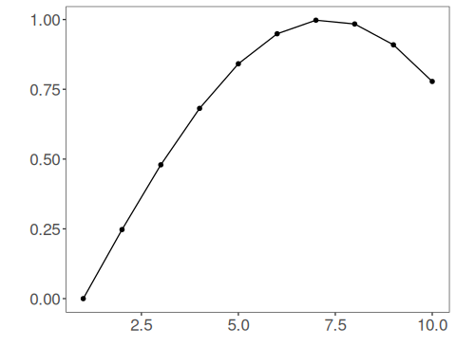
References - Ogasawara, E., Martinez, L. C., De Oliveira, D., Zimbrão, G., Pappa, G. L., Mattoso, M. (2010). Adaptive Normalization: A novel data normalization approach for non-stationary time series. Proceedings of the International Joint Conference on Neural Networks (IJCNN). doi:10.1109/IJCNN.2010.5596746

