Adaptive Softdivide Normalization
About the technique - Softdivide adaptive normalization blends subtractive and divisive behavior through a stabilized denominator. - It is useful when the series can be close to zero in some windows but still exhibit heteroscedastic scaling in others. - Within the adaptive-normalization family implemented by ts_norm_an(), this corresponds to operation = "softdivide".
Didactic goal: see how a smooth transition between additive and relative normalization regimes can stabilize windows without losing scale comparability.
source(url("https://raw.githubusercontent.com/cefet-rj-dal/tspredit/main/examples/seed.R"))
# Adaptive Softdivide Normalization
# Installing the package (if needed)
#install.packages("tspredit")
We start by loading the packages used throughout this example.
# Loading the packages
library(daltoolbox)
library(tspredit)
We load the example series that will be used throughout the demonstration.
# Series for study
data(tsd)
Before moving on, we visualize the series so the effect of the next transformation can be compared against the original signal.
# Series visualization
library(ggplot2)
plot_ts(x = tsd$x, y = tsd$y) + theme(text = element_text(size = 16))
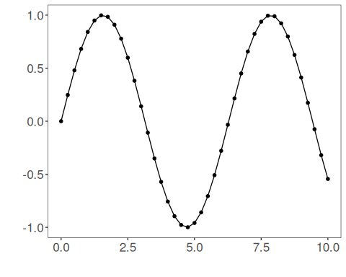
The next step organizes the series into sliding windows, which is the tabular representation used by the later transformations and models.
# Sliding windows
sw_size <- 10
ts <- ts_data(tsd$y, sw_size)
ts_head(ts, 3)
## t9 t8 t7 t6 t5 t4 t3 t2 t1 t0
## [1,] 0.0000000 0.2474040 0.4794255 0.6816388 0.8414710 0.9489846 0.9974950 0.9839859 0.9092974 0.7780732
## [2,] 0.2474040 0.4794255 0.6816388 0.8414710 0.9489846 0.9974950 0.9839859 0.9092974 0.7780732 0.5984721
## [3,] 0.4794255 0.6816388 0.8414710 0.9489846 0.9974950 0.9839859 0.9092974 0.7780732 0.5984721 0.3816610
summary(ts[,10])
## t0
## Min. :-0.99929
## 1st Qu.:-0.55091
## Median : 0.05397
## Mean : 0.02988
## 3rd Qu.: 0.63279
## Max. : 0.99460
We now apply the smooth hybrid normalization operator.
# Softdivide adaptive normalization
preproc <- ts_norm_an(operation = "softdivide", scale = "sd", lambda = 1)
set_example_seed()
preproc <- fit(preproc, ts)
tst <- transform(preproc, ts)
ts_head(tst, 3)
## t9 t8 t7 t6 t5 t4 t3 t2 t1 t0
## [1,] 0.2285699 0.3253376 0.4160887 0.4951808 0.5576963 0.5997483 0.6187223 0.6134385 0.5842254 0.5328994
## [2,] 0.3067719 0.3952724 0.4724030 0.5333681 0.5743772 0.5928807 0.5877279 0.5592393 0.5091862 0.4406806
## [3,] 0.3907643 0.4674532 0.5280693 0.5688436 0.5872411 0.5821178 0.5537923 0.5040258 0.4359125 0.3536873
summary(tst[,10])
## t0
## Min. :0.06219
## 1st Qu.:0.20406
## Median :0.42391
## Mean :0.45306
## 3rd Qu.:0.69267
## Max. :0.93023
plot_ts(y = ts[1,]) + theme(text = element_text(size = 16))
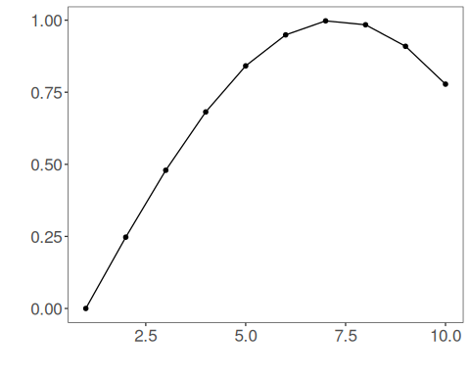
The denominator combines a local scale term and a level-proportional term. As the adaptive mean approaches zero, the transformation behaves more like a stabilized difference; as the local level grows, it behaves more like a relative normalization.
References - Ogasawara, E., Martinez, L. C., De Oliveira, D., Zimbrão, G., Pappa, G. L., Mattoso, M. (2010). Adaptive Normalization: A novel data normalization approach for non-stationary time series. Proceedings of the International Joint Conference on Neural Networks (IJCNN). doi:10.1109/IJCNN.2010.5596746 - Huber, P. J. (1964). Robust Estimation of a Location Parameter. Annals of Mathematical Statistics, 35(1), 73-101. doi:10.1214/aoms/1177703732

