Adaptive Subtractive Normalization
About the technique
- Subtractive adaptive normalization removes the adaptive local level from each window.
- It is useful when the relevant signal is a deviation around a moving baseline, especially near zero where divisive normalization can become unstable.
- Within the adaptive-normalization family implemented by ts_norm_an(), this corresponds to operation = "subtract".
Didactic goal: see adaptive normalization as a local detrending operator that preserves additive contrasts.
source(url("https://raw.githubusercontent.com/cefet-rj-dal/tspredit/main/examples/seed.R"))
# Adaptive Subtractive Normalization
# Installing the package (if needed)
#install.packages("tspredit")
We start by loading the packages used throughout this example.
library(daltoolbox)
library(tspredit)
library(ggplot2)
We load the example series that will be used throughout the demonstration.
data(tsd)
The first plot shows the original series. This is the common visual reference for all normalization examples in this folder.
plot_ts(x = tsd$x, y = tsd$y) + theme(text = element_text(size = 16))
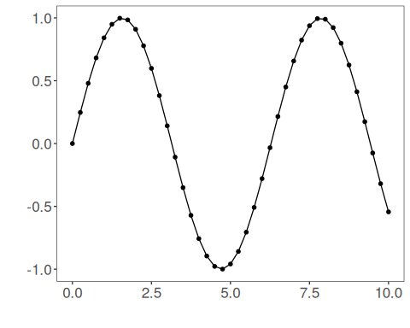
The next step organizes the series into sliding windows, which is the tabular representation used by the later transformations and models.
sw_size <- 10
ts <- ts_data(tsd$y, sw_size)
ts_head(ts, 3)
## t9 t8 t7 t6 t5 t4 t3 t2 t1 t0
## [1,] 0.0000000 0.2474040 0.4794255 0.6816388 0.8414710 0.9489846 0.9974950 0.9839859 0.9092974 0.7780732
## [2,] 0.2474040 0.4794255 0.6816388 0.8414710 0.9489846 0.9974950 0.9839859 0.9092974 0.7780732 0.5984721
## [3,] 0.4794255 0.6816388 0.8414710 0.9489846 0.9974950 0.9839859 0.9092974 0.7780732 0.5984721 0.3816610
summary(ts[, 10])
## t0
## Min. :-0.99929
## 1st Qu.:-0.55091
## Median : 0.05397
## Mean : 0.02988
## 3rd Qu.: 0.63279
## Max. : 0.99460
We now apply the subtractive version of adaptive normalization and compare the supervised target column (t0) before and after the transformation.
preproc <- ts_norm_an(operation = "subtract")
set_example_seed()
preproc <- fit(preproc, ts)
tst <- transform(preproc, ts)
ts_head(tst, 3)
## t9 t8 t7 t6 t5 t4 t3 t2 t1 t0
## [1,] 0.1770086 0.2931936 0.4021548 0.4971174 0.5721773 0.6226675 0.6454487 0.6391047 0.6040297 0.5424046
## [2,] 0.2650884 0.3740495 0.4690122 0.5440720 0.5945622 0.6173435 0.6109994 0.5759245 0.5142994 0.4299558
## [3,] 0.3677446 0.4627073 0.5377671 0.5882573 0.6110386 0.6046945 0.5696195 0.5079945 0.4236508 0.3218327
summary(tst[, 10])
## t0
## Min. :0.04995
## 1st Qu.:0.15185
## Median :0.41183
## Mean :0.44854
## 3rd Qu.:0.73197
## Max. :0.94995
compare_t0 <- rbind(
data.frame(idx = seq_len(nrow(ts)), value = as.vector(ts[, ncol(ts)]), series = "original t0"),
data.frame(idx = seq_len(nrow(tst)), value = as.vector(tst[, ncol(tst)]), series = "transformed t0")
)
ggplot(compare_t0, aes(x = idx, y = value, color = series)) +
geom_line(linewidth = 0.7) +
theme_minimal(base_size = 14)
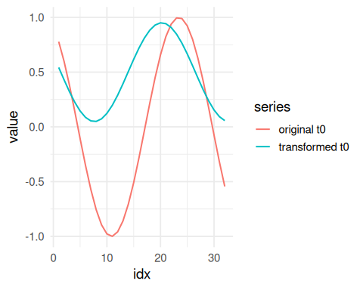
What to observe
- The transformed target behaves like a moving-baseline deviation.
- This is the safest adaptive choice when the local reference level can be close to zero.
References
- Ogasawara, E., Martinez, L. C., De Oliveira, D., Zimbrão, G., Pappa, G. L., Mattoso, M. (2010). Adaptive Normalization: A novel data normalization approach for non-stationary time series. Proceedings of the International Joint Conference on Neural Networks (IJCNN). doi:10.1109/IJCNN.2010.5596746

