Differencing Normalization
About the technique - Differencing replaces each value by its change relative to the previous observation. - This reduces trend effects and often makes the series easier to scale and model.
Didactic goal: see how stabilization by differencing changes both the level and the interpretation of the series.
source(url("https://raw.githubusercontent.com/cefet-rj-dal/tspredit/main/examples/seed.R"))
# Normalization by Differences (Diff)
# Installing the package (if needed)
#install.packages("tspredit")
We start by loading the packages used throughout this example.
# Loading the packages
library(daltoolbox)
library(tspredit)
We load the example series that will be used throughout the demonstration.
# Series for study
data(tsd)
Before moving on, we visualize the series so the effect of the next transformation can be compared against the original signal.
# Series visualization
library(ggplot2)
plot_ts(x=tsd$x, y=tsd$y) + theme(text = element_text(size=16))
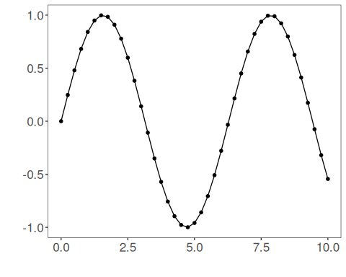
The next step organizes the series into sliding windows, which is the tabular representation used by the later transformations and models.
# Sliding windows
sw_size <- 10
ts <- ts_data(tsd$y, sw_size)
ts_head(ts, 3)
## t9 t8 t7 t6 t5 t4 t3 t2 t1 t0
## [1,] 0.0000000 0.2474040 0.4794255 0.6816388 0.8414710 0.9489846 0.9974950 0.9839859 0.9092974 0.7780732
## [2,] 0.2474040 0.4794255 0.6816388 0.8414710 0.9489846 0.9974950 0.9839859 0.9092974 0.7780732 0.5984721
## [3,] 0.4794255 0.6816388 0.8414710 0.9489846 0.9974950 0.9839859 0.9092974 0.7780732 0.5984721 0.3816610
summary(ts[,10])
## t0
## Min. :-0.99929
## 1st Qu.:-0.55091
## Median : 0.05397
## Mean : 0.02988
## 3rd Qu.: 0.63279
## Max. : 0.99460
This plot isolates the target column so it is easier to understand what the model will ultimately try to predict.
# Target (t0) visualization after windowing
library(ggplot2)
plot_ts(y=ts[,10]) + theme(text = element_text(size=16))
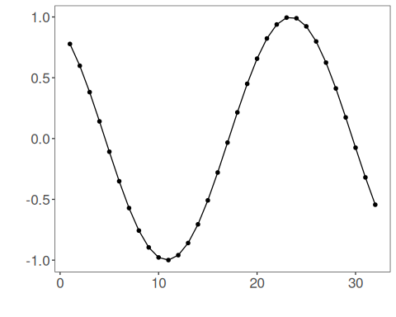
We fit the normalizer on the current data and then transform the series so the rescaled values can be inspected.
# Normalization (fit and transform)
preproc <- ts_norm_diff()
set_example_seed()
preproc <- fit(preproc, ts)
tst <- transform(preproc, ts)
ts_head(tst, 3)
## t8 t7 t6 t5 t4 t3 t2 t1 t0
## [1,] 0.9982009 0.9672887 0.9073861 0.8222178 0.7170790 0.5985067 0.4738732 0.3509276 0.23731412
## [2,] 0.9672887 0.9073861 0.8222178 0.7170790 0.5985067 0.4738732 0.3509276 0.2373141 0.14009662
## [3,] 0.9073861 0.8222178 0.7170790 0.5985067 0.4738732 0.3509276 0.2373141 0.1400966 0.06531964
summary(tst[,9])
## t0
## Min. :0.00000
## 1st Qu.:0.06333
## Median :0.29337
## Mean :0.40975
## 3rd Qu.:0.75129
## Max. :1.00000
plot_ts(y=ts[,9]) + theme(text = element_text(size=16))
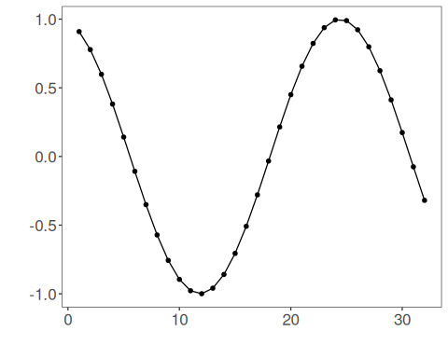
References - G. E. P. Box, G. M. Jenkins, G. C. Reinsel, and G. M. Ljung (2015). Time Series Analysis: Forecasting and Control. Wiley.

