Adaptive Asinh Normalization
About the technique - Adaptive asinh normalization applies an inverse-hyperbolic-sine contrast around the adaptive local level. - It is useful when the analyst wants a transformation that is approximately linear near zero and progressively log-like for larger magnitudes. - Within the adaptive-normalization family implemented by ts_norm_an(), this corresponds to operation = "asinh".
Didactic goal: understand a smooth nonlinear alternative that connects additive and multiplicative interpretations without a hard switch.
source(url("https://raw.githubusercontent.com/cefet-rj-dal/tspredit/main/examples/seed.R"))
# Adaptive Asinh Normalization
# Installing the package (if needed)
#install.packages("tspredit")
We start by loading the packages used throughout this example.
# Loading the packages
library(daltoolbox)
library(tspredit)
We load the example series that will be used throughout the demonstration.
# Series for study
data(tsd)
Before moving on, we visualize the series so the effect of the next transformation can be compared against the original signal.
# Series visualization
library(ggplot2)
plot_ts(x = tsd$x, y = tsd$y) + theme(text = element_text(size = 16))
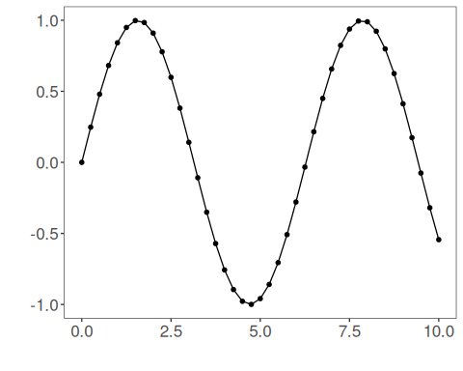
The next step organizes the series into sliding windows, which is the tabular representation used by the later transformations and models.
# Sliding windows
sw_size <- 10
ts <- ts_data(tsd$y, sw_size)
ts_head(ts, 3)
## t9 t8 t7 t6 t5 t4 t3 t2 t1 t0
## [1,] 0.0000000 0.2474040 0.4794255 0.6816388 0.8414710 0.9489846 0.9974950 0.9839859 0.9092974 0.7780732
## [2,] 0.2474040 0.4794255 0.6816388 0.8414710 0.9489846 0.9974950 0.9839859 0.9092974 0.7780732 0.5984721
## [3,] 0.4794255 0.6816388 0.8414710 0.9489846 0.9974950 0.9839859 0.9092974 0.7780732 0.5984721 0.3816610
summary(ts[,10])
## t0
## Min. :-0.99929
## 1st Qu.:-0.55091
## Median : 0.05397
## Mean : 0.02988
## 3rd Qu.: 0.63279
## Max. : 0.99460
We now apply the adaptive asinh operator.
# Adaptive asinh normalization
preproc <- ts_norm_an(operation = "asinh", scale = "sd", lambda = 1)
set_example_seed()
preproc <- fit(preproc, ts)
tst <- transform(preproc, ts)
ts_head(tst, 3)
## t9 t8 t7 t6 t5 t4 t3 t2 t1 t0
## [1,] 0.2262389 0.3352009 0.4289621 0.5011678 0.5519707 0.5832954 0.5967386 0.5930364 0.5719840 0.5324504
## [2,] 0.3189801 0.4108290 0.4818765 0.5320312 0.5630196 0.5763321 0.5726651 0.5518244 0.5127444 0.4537091
## [3,] 0.4069396 0.4777221 0.5277275 0.5586382 0.5719204 0.5682616 0.5474698 0.5084945 0.4496521 0.3696621
summary(tst[,10])
## t0
## Min. :0.06292
## 1st Qu.:0.19582
## Median :0.44171
## Mean :0.45703
## 3rd Qu.:0.68093
## Max. :0.94882
plot_ts(y = ts[1,]) + theme(text = element_text(size = 16))
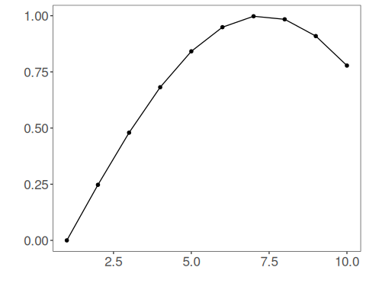
Near zero, the asinh operator behaves approximately linearly; for larger magnitudes it becomes progressively closer to a log-like contrast. This gives a continuous bridge between additive and relative normalization views.
References - Burbidge, J. B., Magee, L., Robb, A. L. (1988). Alternative Transformations to Handle Extreme Values of the Dependent Variable. Journal of the American Statistical Association, 83(401), 123-127. - Bellemare, M. F., Wichman, C. J. (2020). Elasticities and the Inverse Hyperbolic Sine Transformation. Oxford Bulletin of Economics and Statistics, 82(1), 50-61. doi:10.1111/obes.12325

