Adaptive Softdivide Normalization
About the technique
- Softdivide adaptive normalization blends subtractive and divisive behavior through a stabilized denominator.
- It is useful when the series can be close to zero in some windows but still exhibit heteroscedastic scaling in others.
- Within the adaptive-normalization family implemented by ts_norm_an(), this corresponds to operation = "softdivide".
Didactic goal: see how a smooth transition between additive and relative normalization regimes can stabilize windows without losing scale comparability.
source(url("https://raw.githubusercontent.com/cefet-rj-dal/tspredit/main/examples/seed.R"))
# Adaptive Softdivide Normalization
# Installing the package (if needed)
#install.packages("tspredit")
We start by loading the packages used throughout this example.
library(daltoolbox)
library(tspredit)
library(ggplot2)
We load the example series that will be used throughout the demonstration.
data(tsd)
The first plot shows the original series. This is the common visual reference for all normalization examples in this folder.
plot_ts(x = tsd$x, y = tsd$y) + theme(text = element_text(size = 16))
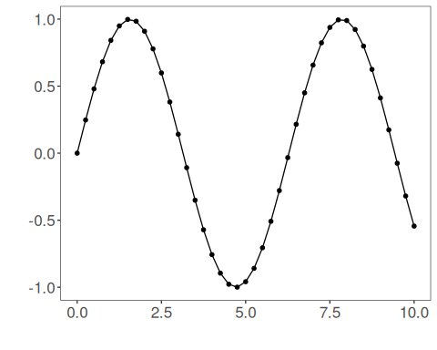
The next step organizes the series into sliding windows, which is the tabular representation used by the later transformations and models.
sw_size <- 10
ts <- ts_data(tsd$y, sw_size)
ts_head(ts, 3)
## t9 t8 t7 t6 t5 t4 t3 t2 t1 t0
## [1,] 0.0000000 0.2474040 0.4794255 0.6816388 0.8414710 0.9489846 0.9974950 0.9839859 0.9092974 0.7780732
## [2,] 0.2474040 0.4794255 0.6816388 0.8414710 0.9489846 0.9974950 0.9839859 0.9092974 0.7780732 0.5984721
## [3,] 0.4794255 0.6816388 0.8414710 0.9489846 0.9974950 0.9839859 0.9092974 0.7780732 0.5984721 0.3816610
summary(ts[, 10])
## t0
## Min. :-0.99929
## 1st Qu.:-0.55091
## Median : 0.05397
## Mean : 0.02988
## 3rd Qu.: 0.63279
## Max. : 0.99460
We now apply the smooth hybrid normalization operator and compare the supervised target column (t0) before and after the transformation.
preproc <- ts_norm_an(operation = "softdivide", scale = "sd", lambda = 1)
set_example_seed()
preproc <- fit(preproc, ts)
tst <- transform(preproc, ts)
ts_head(tst, 3)
## t9 t8 t7 t6 t5 t4 t3 t2 t1 t0
## [1,] 0.2285699 0.3253376 0.4160887 0.4951808 0.5576963 0.5997483 0.6187223 0.6134385 0.5842254 0.5328994
## [2,] 0.3067719 0.3952724 0.4724030 0.5333681 0.5743772 0.5928807 0.5877279 0.5592393 0.5091862 0.4406806
## [3,] 0.3907643 0.4674532 0.5280693 0.5688436 0.5872411 0.5821178 0.5537923 0.5040258 0.4359125 0.3536873
summary(tst[, 10])
## t0
## Min. :0.06219
## 1st Qu.:0.20406
## Median :0.42391
## Mean :0.45306
## 3rd Qu.:0.69267
## Max. :0.93023
compare_t0 <- rbind(
data.frame(idx = seq_len(nrow(ts)), value = as.vector(ts[, ncol(ts)]), series = "original t0"),
data.frame(idx = seq_len(nrow(tst)), value = as.vector(tst[, ncol(tst)]), series = "transformed t0")
)
ggplot(compare_t0, aes(x = idx, y = value, color = series)) +
geom_line(linewidth = 0.7) +
theme_minimal(base_size = 14)
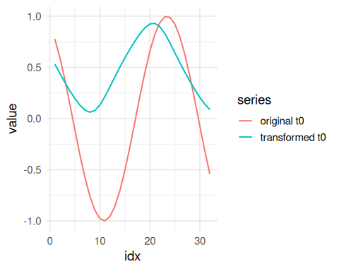
What to observe
- The transformed target behaves more like a difference near zero and more like a ratio at higher levels.
- This is the main compromise operator of the adaptive-normalization family.
References
- Ogasawara, E., Martinez, L. C., De Oliveira, D., Zimbrão, G., Pappa, G. L., Mattoso, M. (2010). Adaptive Normalization: A novel data normalization approach for non-stationary time series. Proceedings of the International Joint Conference on Neural Networks (IJCNN). doi:10.1109/IJCNN.2010.5596746
- Huber, P. J. (1964). Robust Estimation of a Location Parameter. Annals of Mathematical Statistics, 35(1), 73-101. doi:10.1214/aoms/1177703732

