Adaptive Asinh Normalization
About the technique
- Adaptive asinh normalization applies an inverse-hyperbolic-sine contrast around the adaptive local level.
- It is useful when the analyst wants a transformation that is approximately linear near zero and progressively log-like for larger magnitudes.
- Within the adaptive-normalization family implemented by ts_norm_an(), this corresponds to operation = "asinh".
Didactic goal: understand a smooth nonlinear alternative that connects additive and multiplicative interpretations without a hard switch.
source(url("https://raw.githubusercontent.com/cefet-rj-dal/tspredit/main/examples/seed.R"))
# Adaptive Asinh Normalization
# Installing the package (if needed)
#install.packages("tspredit")
We start by loading the packages used throughout this example.
library(daltoolbox)
library(tspredit)
library(ggplot2)
We load the example series that will be used throughout the demonstration.
data(tsd)
The first plot shows the original series. This is the common visual reference for all normalization examples in this folder.
plot_ts(x = tsd$x, y = tsd$y) + theme(text = element_text(size = 16))
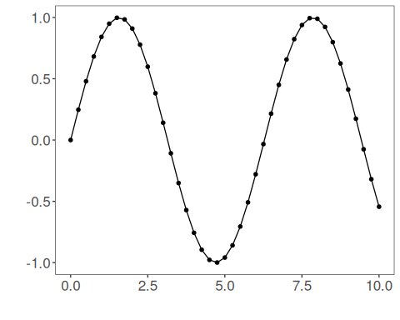
The next step organizes the series into sliding windows, which is the tabular representation used by the later transformations and models.
sw_size <- 10
ts <- ts_data(tsd$y, sw_size)
ts_head(ts, 3)
## t9 t8 t7 t6 t5 t4 t3 t2 t1 t0
## [1,] 0.0000000 0.2474040 0.4794255 0.6816388 0.8414710 0.9489846 0.9974950 0.9839859 0.9092974 0.7780732
## [2,] 0.2474040 0.4794255 0.6816388 0.8414710 0.9489846 0.9974950 0.9839859 0.9092974 0.7780732 0.5984721
## [3,] 0.4794255 0.6816388 0.8414710 0.9489846 0.9974950 0.9839859 0.9092974 0.7780732 0.5984721 0.3816610
summary(ts[, 10])
## t0
## Min. :-0.99929
## 1st Qu.:-0.55091
## Median : 0.05397
## Mean : 0.02988
## 3rd Qu.: 0.63279
## Max. : 0.99460
We now apply the adaptive asinh operator and compare the supervised target column (t0) before and after the transformation.
preproc <- ts_norm_an(operation = "asinh", scale = "sd", lambda = 1)
set_example_seed()
preproc <- fit(preproc, ts)
tst <- transform(preproc, ts)
ts_head(tst, 3)
## t9 t8 t7 t6 t5 t4 t3 t2 t1 t0
## [1,] 0.2262389 0.3352009 0.4289621 0.5011678 0.5519707 0.5832954 0.5967386 0.5930364 0.5719840 0.5324504
## [2,] 0.3189801 0.4108290 0.4818765 0.5320312 0.5630196 0.5763321 0.5726651 0.5518244 0.5127444 0.4537091
## [3,] 0.4069396 0.4777221 0.5277275 0.5586382 0.5719204 0.5682616 0.5474698 0.5084945 0.4496521 0.3696621
summary(tst[, 10])
## t0
## Min. :0.06292
## 1st Qu.:0.19582
## Median :0.44171
## Mean :0.45703
## 3rd Qu.:0.68093
## Max. :0.94882
compare_t0 <- rbind(
data.frame(idx = seq_len(nrow(ts)), value = as.vector(ts[, ncol(ts)]), series = "original t0"),
data.frame(idx = seq_len(nrow(tst)), value = as.vector(tst[, ncol(tst)]), series = "transformed t0")
)
ggplot(compare_t0, aes(x = idx, y = value, color = series)) +
geom_line(linewidth = 0.7) +
theme_minimal(base_size = 14)
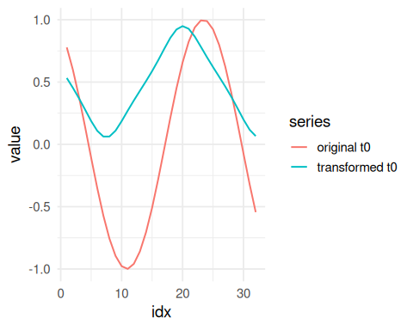
What to observe
- Near zero, the transformed target stays close to an additive contrast.
- For larger deviations, the transformation becomes progressively more log-like without switching abruptly.
References
- Burbidge, J. B., Magee, L., Robb, A. L. (1988). Alternative Transformations to Handle Extreme Values of the Dependent Variable. Journal of the American Statistical Association, 83(401), 123-127.
- Bellemare, M. F., Wichman, C. J. (2020). Elasticities and the Inverse Hyperbolic Sine Transformation. Oxford Bulletin of Economics and Statistics, 82(1), 50-61. doi:10.1111/obes.12325

