Adaptive Normalization Visual Comparison
This notebook compares the main adaptive normalization operators on synthetic series designed to stress different theoretical axes of the method.
What you will learn - How divisive normalization reacts when the adaptive level is close to zero - How subtractive normalization behaves under changing amplitude - How softdivide interpolates between additive and relative behavior - How asinh changes the geometry of local deviations
source(url("https://raw.githubusercontent.com/cefet-rj-dal/tspredit/main/examples/seed.R"))
# Adaptive Normalization Visual Comparison
# Installing the package (if needed)
#install.packages("tspredit")
We load the packages required by this example.
library(daltoolbox)
library(tspredit)
library(ggplot2)
We build four synthetic series, each emphasizing one regime where the normalizers behave differently.
set_example_seed()
n <- 200
t <- seq_len(n)
synthetic <- list(
near_zero = 0.03 * sin(t / 5) + rnorm(n, sd = 0.01),
level_shift = c(rep(0.3, 70), rep(1.2, 60), rep(0.6, 70)) + 0.08 * sin(t / 7),
heteroscedastic = sin(t / 6) * seq(0.2, 2.2, length.out = n),
mixed = 0.2 * sin(t / 8) + seq(-0.4, 1.8, length.out = n) + rnorm(n, sd = seq(0.02, 0.25, length.out = n))
)
To keep the comparison fair, every operator uses the same sliding-window view.
ops <- list(
divide = ts_norm_an(operation = "divide"),
subtract = ts_norm_an(operation = "subtract"),
softdivide = ts_norm_an(operation = "softdivide", scale = "sd", lambda = 1),
asinh = ts_norm_an(operation = "asinh", scale = "sd", lambda = 1)
)
collect_transforms <- function(y, series_name) {
tsw <- ts_data(y, 12)
out <- data.frame()
for (op_name in names(ops)) {
preproc <- ops[[op_name]]
preproc <- fit(preproc, tsw)
yt <- transform(preproc, tsw)
out <- rbind(
out,
data.frame(
idx = seq_len(nrow(yt)),
value = as.vector(yt[, ncol(yt)]),
operator = op_name,
series = series_name
)
)
}
out
}
comparison <- do.call(
rbind,
Map(collect_transforms, synthetic, names(synthetic))
)
This plot compares the transformed target dimension (t0) across series and operators.
ggplot(comparison, aes(x = idx, y = value, color = operator)) +
geom_line(linewidth = 0.5) +
facet_wrap(~ series, scales = "free_y", ncol = 2) +
theme_minimal(base_size = 14)
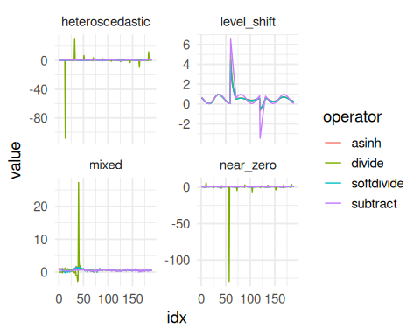
Interpretation guide - near_zero: checks whether the operator remains stable when the local level almost vanishes. - level_shift: checks how quickly the operator adapts to abrupt mean changes. - heteroscedastic: checks whether similar shapes at different amplitudes become more comparable. - mixed: combines drift, variance growth, and oscillation to reveal trade-offs between the operators.
References - Ogasawara, E., Martinez, L. C., De Oliveira, D., Zimbrão, G., Pappa, G. L., Mattoso, M. (2010). Adaptive Normalization: A novel data normalization approach for non-stationary time series. Proceedings of the International Joint Conference on Neural Networks (IJCNN). doi:10.1109/IJCNN.2010.5596746 - Huber, P. J. (1964). Robust Estimation of a Location Parameter. Annals of Mathematical Statistics, 35(1), 73-101. doi:10.1214/aoms/1177703732 - Burbidge, J. B., Magee, L., Robb, A. L. (1988). Alternative Transformations to Handle Extreme Values of the Dependent Variable. Journal of the American Statistical Association, 83(401), 123-127.

