Adaptive Normalization Visual Comparison
This notebook compares the main adaptive normalization operators on synthetic series designed to stress different theoretical axes of the method.
What you will learn
- How divisive normalization reacts when the adaptive level is close to zero
- How subtractive normalization behaves under changing amplitude
- How softdivide interpolates between additive and relative behavior
- How asinh changes the geometry of local deviations
source(url("https://raw.githubusercontent.com/cefet-rj-dal/tspredit/main/examples/seed.R"))
# Adaptive Normalization Visual Comparison
# Installing the package (if needed)
#install.packages("tspredit")
We load the packages required by this example.
library(daltoolbox)
library(tspredit)
library(ggplot2)
We build four synthetic series, each emphasizing one regime where the normalizers behave differently.
set_example_seed()
n <- 200
t <- seq_len(n)
synthetic <- list(
near_zero = 0.03 * sin(t / 5) + rnorm(n, sd = 0.01),
level_shift = c(rep(0.3, 70), rep(1.2, 60), rep(0.6, 70)) + 0.08 * sin(t / 7),
heteroscedastic = sin(t / 6) * seq(0.2, 2.2, length.out = n),
mixed = 0.2 * sin(t / 8) + seq(-0.4, 1.8, length.out = n) + rnorm(n, sd = seq(0.02, 0.25, length.out = n))
)

Comparison Strategy
To keep the comparison fair, every operator uses the same sliding-window view. We inspect the operators in two complementary ways:
- a fixed anchor window, so we can compare the transformed lag profile directly
- the transformed target dimension (t0) across time, which is the signal most directly consumed by the supervised pipeline
This separation matters. If we only plot the transformed target across time, the comparison becomes hard to read because each operator is reacting to a different local window at each time step. The anchor-window plot removes this confounding factor and answers a simpler question: how do the operators transform the same local pattern?
ops <- list(
divide = ts_norm_an(operation = "divide"),
subtract = ts_norm_an(operation = "subtract"),
softdivide = ts_norm_an(operation = "softdivide", scale = "sd", lambda = 1),
asinh = ts_norm_an(operation = "asinh", scale = "sd", lambda = 1)
)
compute_reference <- getFromNamespace("compute_adaptive_reference", "tspredit")
apply_operation <- getFromNamespace("apply_adaptive_operation", "tspredit")
anchor_row <- function(series_name, tsw) {
if (series_name == "level_shift") {
return(min(70, nrow(tsw)))
}
nrow(tsw)
}
collect_window_profiles <- function(y, series_name) {
tsw <- ts_data(y, 12)
anchor <- anchor_row(series_name, tsw)
out <- data.frame()
for (op_name in names(ops)) {
preproc <- fit(ops[[op_name]], tsw)
window_ref <- compute_reference(preproc, tsw[anchor, , drop = FALSE])
yw <- apply_operation(
preproc,
tsw[anchor, , drop = FALSE],
window_ref$center,
window_ref$scale
)
out <- rbind(
out,
data.frame(
lag = factor(colnames(tsw), levels = colnames(tsw)),
value = as.vector(yw),
operator = op_name,
series = series_name
)
)
}
out
}
collect_t0_transforms <- function(y, series_name) {
tsw <- ts_data(y, 12)
out <- data.frame()
for (op_name in names(ops)) {
preproc <- ops[[op_name]]
preproc <- fit(preproc, tsw)
yt <- transform(preproc, tsw)
out <- rbind(
out,
data.frame(
idx = seq_len(nrow(yt)),
value = as.vector(yt[, ncol(yt)]),
operator = op_name,
series = series_name
)
)
}
out
}
window_profiles <- do.call(
rbind,
Map(collect_window_profiles, synthetic, names(synthetic))
)
comparison_t0 <- do.call(
rbind,
Map(collect_t0_transforms, synthetic, names(synthetic))
)
This plot compares one fixed window per series. It is the clearest way to see how each operator transforms the same lag profile.
ggplot(window_profiles, aes(x = lag, y = value, color = operator, group = operator)) +
geom_line(linewidth = 0.7) +
geom_point(size = 1.2) +
facet_wrap(~ series, scales = "free_y", ncol = 2) +
theme_minimal(base_size = 14)
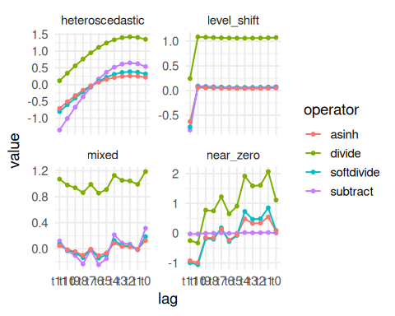

What To Look For In The Fixed-Window Plot
Near-zero regime
- divide can become very aggressive because small adaptive levels amplify the ratio
- subtract stays stable because it only removes the local level
- softdivide should stay closer to subtract here than to divide
Level-shift regime
- the main question is how the operators encode an abrupt change in local level
- divide and softdivide can look similar if the level term dominates the reference scale
Heteroscedastic regime
- the key question is whether similar oscillations at different amplitudes become more comparable
- subtract removes level but does not directly normalize scale
- divide and softdivide should compress amplitude differences more strongly
Mixed regime
- this combines drift, oscillation, and changing variance
- it is the best block to inspect overall trade-offs rather than a single ideal behavior
This second plot compares the transformed target dimension (t0) across time. It is still useful, but it becomes easier to read after seeing the fixed-window comparison above.
ggplot(comparison_t0, aes(x = idx, y = value, color = operator)) +
geom_line(linewidth = 0.5) +
facet_wrap(~ series, scales = "free_y", ncol = 2) +
theme_minimal(base_size = 14)
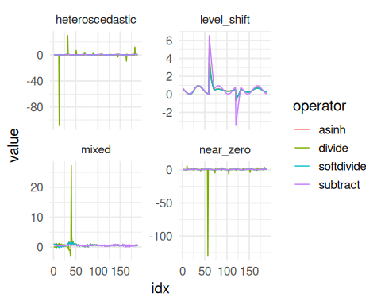

What To Look For In The t0 Plot
- This plot shows how the final supervised target changes over time after normalization.
- It is useful for understanding temporal stability, but it is less direct than the fixed-window comparison.
- If two operators look close here, that does not necessarily mean they are identical. It may only mean that, for that series and that time range, both induce similar transformed targets.

Why Some Curves Can Look Similar
- divide and softdivide can look close when the adaptive level dominates the local scale term. In that regime, softdivide approaches divisive behavior.
- softdivide and asinh can also look close when the normalized deviations stay in a moderate range, because asinh(z) behaves almost linearly around the origin.
- The near_zero and heteroscedastic blocks are usually the most informative ones for separating the four operators visually.

Reading Summary
If you want a quick reading of the comparison, focus on these questions:
- Which operator stays stable when the local level is close to zero?
- Which operator best preserves comparability across changing amplitudes?
- Which operator produces the smoothest compromise between additive and relative behavior?
In most practical cases:
- subtract is the safest additive baseline
- divide is the strongest relative normalizer, but it is fragile near zero
- softdivide is the main compromise operator
- asinh is the smooth nonlinear alternative when you want a bridge between additive and multiplicative interpretations
References
- Ogasawara, E., Martinez, L. C., De Oliveira, D., Zimbrão, G., Pappa, G. L., Mattoso, M. (2010). Adaptive Normalization: A novel data normalization approach for non-stationary time series. Proceedings of the International Joint Conference on Neural Networks (IJCNN). doi:10.1109/IJCNN.2010.5596746
- Huber, P. J. (1964). Robust Estimation of a Location Parameter. Annals of Mathematical Statistics, 35(1), 73-101. doi:10.1214/aoms/1177703732
- Burbidge, J. B., Magee, L., Robb, A. L. (1988). Alternative Transformations to Handle Extreme Values of the Dependent Variable. Journal of the American Statistical Association, 83(401), 123-127.

