ARIMA Baseline
About the method - ARIMA models a univariate series with autoregressive terms, differencing, and moving-average terms. - In tspredit, ts_arima() performs automatic order selection and then generates recursive forecasts for the requested horizon.
Didactic goal: learn the classical forecasting baseline before moving to sliding-window machine-learning models.
source(url("https://raw.githubusercontent.com/cefet-rj-dal/tspredit/main/examples/seed.R"))
#install.packages("tspredit")
# Loading the package
library(tspredit)
We load the example series in its raw sequential form, without creating sliding windows yet.
# Series for study (no sliding window)
data(tsd)
ts <- ts_data(tsd$y, 0)
ts_head(ts, 3)
## t0
## [1,] 0.0000000
## [2,] 0.2474040
## [3,] 0.4794255
Before moving on, we visualize the series so the effect of the next transformation can be compared against the original signal.
# Series visualization
library(ggplot2)
plot_ts(x=tsd$x, y=tsd$y) + theme(text = element_text(size=16))
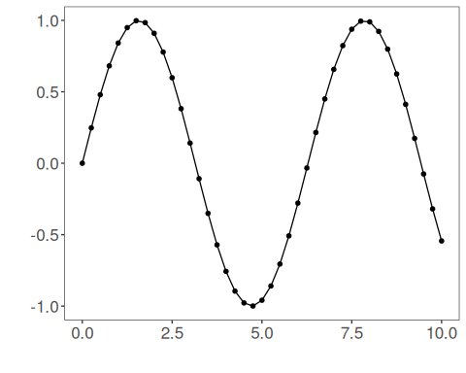
We now preserve the time order and split the raw sequence into train and test partitions.
# Train-test split on the ordered series
samp <- ts_sample(ts, test_size = 5)
ts_head(samp$train, 3)
## t0
## [1,] 0.0000000
## [2,] 0.2474040
## [3,] 0.4794255
ts_head(samp$test, 3)
## t0
## [1,] 0.41211849
## [2,] 0.17388949
## [3,] -0.07515112
This step training the arima model (orders selected automatically).
# Training the ARIMA model (orders selected automatically)
model <- ts_arima(p = 5, d = 0, q = 0)
set_example_seed()
model <- fit(model, x = samp$train)
We first evaluate the in-sample fit so the model adjustment can be compared with the later forecast.
# Fit evaluation (train)
adjust <- predict(model, samp$train)
adjust <- as.vector(adjust)
output <- as.vector(samp$train)
ev_adjust <- evaluate(model, output, adjust)
ev_adjust$mse
## [1] 8.076802e-09
We now generate a five-step forecast on the test segment and compare it with the observed values.
# Forecast on test set (5 steps ahead)
prediction <- predict(model, x = samp$test[1,], steps_ahead = 5)
prediction <- as.vector(prediction)
output <- as.vector(samp$test)
ev_test <- evaluate(model, output, prediction)
ev_test
## $values
## [1] 0.41211849 0.17388949 -0.07515112 -0.31951919 -0.54402111
##
## $prediction
## [1] 0.41211881 0.17388946 -0.07515026 -0.31951936 -0.54401966
##
## $smape
## [1] 3.10581e-06
##
## $mse
## [1] 5.935781e-13
##
## $R2
## [1] 1
##
## $metrics
## mse smape R2
## 1 5.935781e-13 3.10581e-06 1
The final plot compares the observed series, the training adjustment, and the forecasted test horizon.
# Plot comparing actual vs fit (train) and forecast (test)
yvalues <- c(samp$train, samp$test)
plot_ts_pred(y=yvalues, yadj=adjust, ypre=prediction, color_prediction="orange") + theme(text = element_text(size=16))
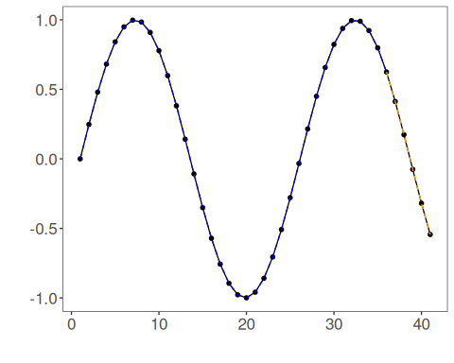
References - G. E. P. Box, G. M. Jenkins, G. C. Reinsel, and G. M. Ljung (2015). Time Series Analysis: Forecasting and Control. Wiley. - R. J. Hyndman and Y. Khandakar (2008). Automatic time series forecasting: The forecast package for R. Journal of Statistical Software, 27(3), 1–22. doi:10.18637/jss.v027.i03

