SVM Regression
About the method - Support Vector Regression learns a nonlinear forecasting function by maximizing margin while controlling prediction error. - It is useful when local linearity is insufficient but the problem still benefits from a strong regularization principle.
Didactic goal: see how a margin-based regressor behaves on lagged time-series inputs.
source(url("https://raw.githubusercontent.com/cefet-rj-dal/tspredit/main/examples/seed.R"))
# Time Series Regression - SVM
# Installing the package (if needed)
#install.packages("tspredit")
We start by loading the packages used throughout this example.
# Loading the packages
library(daltoolbox)
library(tspredit)
We load the example series that will be used throughout the demonstration.
# Series for study and sliding windows
data(tsd)
ts <- ts_data(tsd$y, 10)
ts_head(ts, 3)
## t9 t8 t7 t6 t5 t4 t3 t2 t1 t0
## [1,] 0.0000000 0.2474040 0.4794255 0.6816388 0.8414710 0.9489846 0.9974950 0.9839859 0.9092974 0.7780732
## [2,] 0.2474040 0.4794255 0.6816388 0.8414710 0.9489846 0.9974950 0.9839859 0.9092974 0.7780732 0.5984721
## [3,] 0.4794255 0.6816388 0.8414710 0.9489846 0.9974950 0.9839859 0.9092974 0.7780732 0.5984721 0.3816610
Before moving on, we visualize the series so the effect of the next transformation can be compared against the original signal.
# Series visualization
library(ggplot2)
plot_ts(x=tsd$x, y=tsd$y) + theme(text = element_text(size=16))
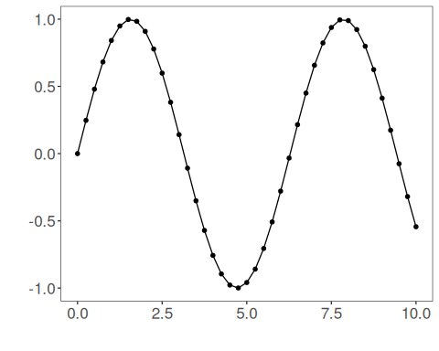
We now preserve the time order, split the data into train and test partitions, and project the windows into inputs and targets.
# Train-test split and projection (X, y)
samp <- ts_sample(ts, test_size = 5)
io_train <- ts_projection(samp$train)
io_test <- ts_projection(samp$test)
We now prepare the preprocessing object that will normalize the inputs before the model is trained.
# Preprocessing (global min-max normalization)
preproc <- ts_norm_gminmax()
We now train the svm model on the prepared training data.
# Training the SVM model
model <- ts_svm(ts_norm_gminmax(), input_size=4)
set_example_seed()
model <- fit(model, x=io_train$input, y=io_train$output)
We first evaluate the in-sample fit so the model adjustment can be compared with the later forecast.
# Fit evaluation (train)
adjust <- predict(model, io_train$input)
adjust <- as.vector(adjust)
output <- as.vector(io_train$output)
ev_adjust <- evaluate(model, output, adjust)
ev_adjust$mse
## [1] 5.130098e-07
We now generate a five-step forecast on the test segment and compare it with the observed values.
# Forecast on test set (5 steps ahead)
prediction <- predict(model, x=io_test$input[1,], steps_ahead=5)
prediction <- as.vector(prediction)
output <- as.vector(io_test$output)
ev_test <- evaluate(model, output, prediction)
ev_test
## $values
## [1] 0.41211849 0.17388949 -0.07515112 -0.31951919 -0.54402111
##
## $prediction
## [1] 0.41268934 0.17333448 -0.07563299 -0.31983409 -0.54481781
##
## $smape
## [1] 0.002684197
##
## $mse
## [1] 3.199991e-07
##
## $R2
## [1] 0.9999972
##
## $metrics
## mse smape R2
## 1 3.199991e-07 0.002684197 0.9999972
The final plot compares the observed series, the training adjustment, and the forecasted test horizon.
# Plot comparing actual vs fit (train) and forecast (test)
yvalues <- c(io_train$output, io_test$output)
plot_ts_pred(y=yvalues, yadj=adjust, ypre=prediction, color_prediction="orange") + theme(text = element_text(size=16))
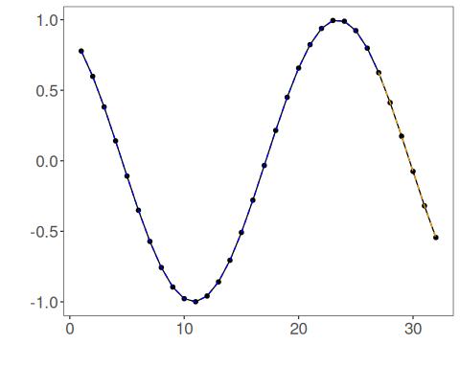
References - A. J. Smola and B. Schölkopf (2004). A tutorial on support vector regression. Statistics and Computing, 14(3), 199–222.

