Random Forest Regression
About the method - Random forests combine many decision trees trained on bootstrap samples and random feature subsets. - In forecasting with lagged windows, they capture nonlinear interactions among lags without requiring explicit parametric assumptions.
Didactic goal: inspect an ensemble baseline that is often strong with little manual feature engineering.
source(url("https://raw.githubusercontent.com/cefet-rj-dal/tspredit/main/examples/seed.R"))
# Time Series Regression - Random Forest
# Installing the package (if needed)
#install.packages("tspredit")
We start by loading the packages used throughout this example.
# Loading the packages
library(daltoolbox)
library(tspredit)
We load the example series that will be used throughout the demonstration.
# Series for study and sliding windows
data(tsd)
ts <- ts_data(tsd$y, 10)
ts_head(ts, 3)
## t9 t8 t7 t6 t5 t4 t3 t2 t1 t0
## [1,] 0.0000000 0.2474040 0.4794255 0.6816388 0.8414710 0.9489846 0.9974950 0.9839859 0.9092974 0.7780732
## [2,] 0.2474040 0.4794255 0.6816388 0.8414710 0.9489846 0.9974950 0.9839859 0.9092974 0.7780732 0.5984721
## [3,] 0.4794255 0.6816388 0.8414710 0.9489846 0.9974950 0.9839859 0.9092974 0.7780732 0.5984721 0.3816610
Before moving on, we visualize the series so the effect of the next transformation can be compared against the original signal.
# Series visualization
library(ggplot2)
plot_ts(x=tsd$x, y=tsd$y) + theme(text = element_text(size=16))
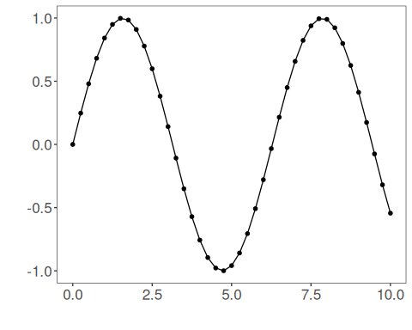
We now preserve the time order, split the data into train and test partitions, and project the windows into inputs and targets.
# Train-test split and projection (X, y)
samp <- ts_sample(ts, test_size = 5)
io_train <- ts_projection(samp$train)
io_test <- ts_projection(samp$test)
We now prepare the preprocessing object that will normalize the inputs before the model is trained.
# Preprocessing (global min-max normalization)
preproc <- ts_norm_gminmax()
We now train the random forest model on the prepared training data. For recursive forecasting, a slightly larger lag set and a less tiny ensemble usually behave better than the smallest possible defaults.
# Training the Random Forest model
model <- ts_rf(ts_norm_gminmax(), input_size = 9, nodesize = 1, ntree = 100)
set_example_seed()
model <- fit(model, x=io_train$input, y=io_train$output)
If you later tune this model, a good first search space is usually:
- input_size near the most recent 6 to 10 lags when the sliding window has size 10;
- nodesize in small values such as c(1, 3, 5);
- ntree in moderate ensembles such as c(50, 100, 200);
- mtry in a small range like 2:5, always respecting the chosen input_size.
We first evaluate the in-sample fit so the model adjustment can be compared with the later forecast.
# Fit evaluation (train)
adjust <- predict(model, io_train$input)
adjust <- as.vector(adjust)
output <- as.vector(io_train$output)
ev_adjust <- evaluate(model, output, adjust)
ev_adjust$mse
## [1] 0.007566375
We now generate a five-step forecast on the test segment and compare it with the observed values.
# Forecast on test set (5 steps ahead)
prediction <- predict(model, x=io_test$input[1,], steps_ahead=5)
prediction <- as.vector(prediction)
output <- as.vector(io_test$output)
ev_test <- evaluate(model, output, prediction)
ev_test
## $values
## [1] 0.41211849 0.17388949 -0.07515112 -0.31951919 -0.54402111
##
## $prediction
## [1] 0.38467363 0.18478678 0.04013553 -0.14855077 -0.32237289
##
## $smape
## [1] 0.6743668
##
## $mse
## [1] 0.01850422
##
## $R2
## [1] 0.8401781
##
## $metrics
## mse smape R2
## 1 0.01850422 0.6743668 0.8401781
The final plot compares the observed series, the training adjustment, and the forecasted test horizon.
# Plot comparing actual vs fit (train) and forecast (test)
yvalues <- c(io_train$output, io_test$output)
plot_ts_pred(y=yvalues, yadj=adjust, ypre=prediction, color_prediction="orange") + theme(text = element_text(size=16))
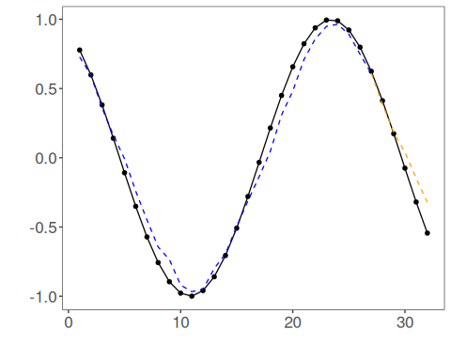
References - L. Breiman (2001). Random Forests. Machine Learning, 45(1), 5–32.

