MLP Regression
About the method - An MLP is a feedforward neural network that maps lagged inputs to the forecast target through hidden nonlinear layers. - Its main modeling choices are the input window, hidden size, regularization, and training iterations.
Didactic goal: learn the core neural forecasting pipeline used as the backbone for later tutorial examples.
source(url("https://raw.githubusercontent.com/cefet-rj-dal/tspredit/main/examples/seed.R"))
# Time Series Regression - MLP
# Installing the package (if needed)
#install.packages("tspredit")
We start by loading the packages used throughout this example.
# Loading the packages
library(daltoolbox)
library(tspredit)
We load the example series that will be used throughout the demonstration.
# Series for study (generates sliding windows t9..t0)
data(tsd)
ts <- ts_data(tsd$y, 10)
ts_head(ts, 3)
## t9 t8 t7 t6 t5 t4 t3 t2 t1 t0
## [1,] 0.0000000 0.2474040 0.4794255 0.6816388 0.8414710 0.9489846 0.9974950 0.9839859 0.9092974 0.7780732
## [2,] 0.2474040 0.4794255 0.6816388 0.8414710 0.9489846 0.9974950 0.9839859 0.9092974 0.7780732 0.5984721
## [3,] 0.4794255 0.6816388 0.8414710 0.9489846 0.9974950 0.9839859 0.9092974 0.7780732 0.5984721 0.3816610
Before moving on, we visualize the series so the effect of the next transformation can be compared against the original signal.
# Original series visualization
library(ggplot2)
plot_ts(x=tsd$x, y=tsd$y) + theme(text = element_text(size=16))
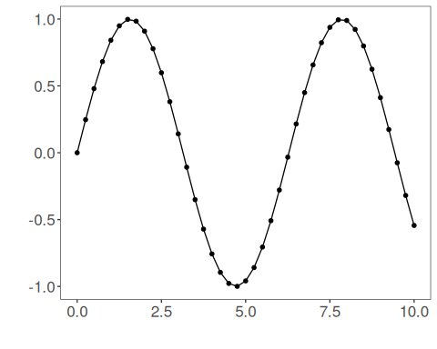
We now preserve the time order, split the data into train and test partitions, and project the windows into inputs and targets.
# Train-test split and projection (X, y)
samp <- ts_sample(ts, test_size = 5)
io_train <- ts_projection(samp$train)
io_test <- ts_projection(samp$test)
We now prepare the preprocessing object that will normalize the inputs before the model is trained.
# Preprocessing (global min-max normalization)
preproc <- ts_norm_gminmax()
We now train the mlp model on the prepared training data.
# Training the MLP model
model <- ts_mlp(ts_norm_gminmax(), input_size=4, size=4, decay=0)
set_example_seed()
model <- fit(model, x=io_train$input, y=io_train$output)
We first evaluate the in-sample fit so the model adjustment can be compared with the later forecast.
# Fit evaluation (train)
adjust <- predict(model, io_train$input)
adjust <- as.vector(adjust)
output <- as.vector(io_train$output)
ev_adjust <- evaluate(model, output, adjust)
ev_adjust$mse
## [1] 1.432577e-05
We now generate a five-step forecast on the test segment and compare it with the observed values.
# Forecast on test set (5 steps ahead)
prediction <- predict(model, x=io_test$input[1,], steps_ahead=5)
prediction <- as.vector(prediction)
output <- as.vector(io_test$output)
ev_test <- evaluate(model, output, prediction)
ev_test
## $values
## [1] 0.41211849 0.17388949 -0.07515112 -0.31951919 -0.54402111
##
## $prediction
## [1] 0.41787725 0.18362848 -0.06273766 -0.30699150 -0.53616730
##
## $smape
## [1] 0.06058831
##
## $mse
## [1] 0.0001001462
##
## $R2
## [1] 0.999135
##
## $metrics
## mse smape R2
## 1 0.0001001462 0.06058831 0.999135
The final plot compares the observed series, the training adjustment, and the forecasted test horizon.
# Plot comparing actual vs fit (train) and forecast (test)
yvalues <- c(io_train$output, io_test$output)
plot_ts_pred(y=yvalues, yadj=adjust, ypre=prediction, color_prediction="orange") + theme(text = element_text(size=16))
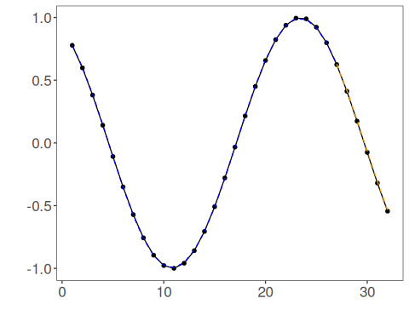
References - D. E. Rumelhart, G. E. Hinton, and R. J. Williams (1986). Learning representations by back-propagating errors. Nature, 323, 533–536.

