ELM Regression
About the method - Extreme Learning Machines use a single hidden layer with randomly assigned hidden weights and a fast output-layer fit. - They are attractive when you want a neural model with much cheaper training than iterative backpropagation.
Didactic goal: compare a fast neural regressor with the more conventional MLP workflow.
source(url("https://raw.githubusercontent.com/cefet-rj-dal/tspredit/main/examples/seed.R"))
# Time Series Regression - ELM
# Installing the package (if needed)
#install.packages("tspredit")
We start by loading the packages used throughout this example.
# Loading the packages
library(daltoolbox)
library(tspredit)
We load the example series that will be used throughout the demonstration.
# Series for study and sliding windows
data(tsd)
ts <- ts_data(tsd$y, 10)
ts_head(ts, 3)
## t9 t8 t7 t6 t5 t4 t3 t2 t1 t0
## [1,] 0.0000000 0.2474040 0.4794255 0.6816388 0.8414710 0.9489846 0.9974950 0.9839859 0.9092974 0.7780732
## [2,] 0.2474040 0.4794255 0.6816388 0.8414710 0.9489846 0.9974950 0.9839859 0.9092974 0.7780732 0.5984721
## [3,] 0.4794255 0.6816388 0.8414710 0.9489846 0.9974950 0.9839859 0.9092974 0.7780732 0.5984721 0.3816610
Before moving on, we visualize the series so the effect of the next transformation can be compared against the original signal.
# Series visualization
library(ggplot2)
plot_ts(x=tsd$x, y=tsd$y) + theme(text = element_text(size=16))
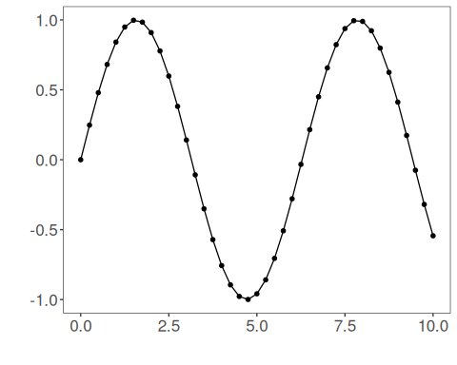
We now preserve the time order, split the data into train and test partitions, and project the windows into inputs and targets.
# Train-test split and projection (X, y)
samp <- ts_sample(ts, test_size = 5)
io_train <- ts_projection(samp$train)
io_test <- ts_projection(samp$test)
We now prepare the preprocessing object that will normalize the inputs before the model is trained.
# Preprocessing (global min-max normalization)
preproc <- ts_norm_gminmax()
We now train the elm model on the prepared training data.
# Training the ELM model
model <- ts_elm(ts_norm_gminmax(), input_size=4, nhid=3, actfun="purelin")
set_example_seed()
model <- fit(model, x=io_train$input, y=io_train$output)
We first evaluate the in-sample fit so the model adjustment can be compared with the later forecast.
# Fit evaluation (train)
adjust <- predict(model, io_train$input)
adjust <- as.vector(adjust)
output <- as.vector(io_train$output)
ev_adjust <- evaluate(model, output, adjust)
ev_adjust$mse
## [1] 2.445432e-27
We now forecast the test set and compare the predicted values with the observed ones.
# Forecast on test set
prediction <- predict(model, x=io_test$input[1,], steps_ahead=5)
prediction <- as.vector(prediction)
output <- as.vector(io_test$output)
ev_test <- evaluate(model, output, prediction)
ev_test
## $values
## [1] 0.41211849 0.17388949 -0.07515112 -0.31951919 -0.54402111
##
## $prediction
## [1] 0.41211849 0.17388949 -0.07515112 -0.31951919 -0.54402111
##
## $smape
## [1] 2.130585e-12
##
## $mse
## [1] 3.675509e-25
##
## $R2
## [1] 1
##
## $metrics
## mse smape R2
## 1 3.675509e-25 2.130585e-12 1
This final plot summarizes the result of the transformation so the effect can be interpreted visually.
# Plot results
yvalues <- c(io_train$output, io_test$output)
plot_ts_pred(y=yvalues, yadj=adjust, ypre=prediction, color_prediction="orange") + theme(text = element_text(size=16))
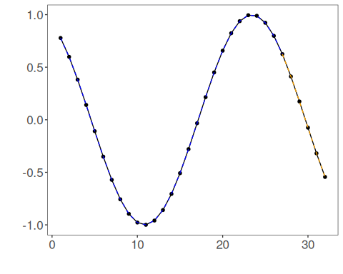
References - G.-B. Huang, Q.-Y. Zhu, and C.-K. Siew (2006). Extreme learning machine: Theory and applications. Neurocomputing, 70(1–3), 489–501.

