LSTM Regression
About the method - LSTM networks are recurrent models designed to retain and update information across ordered inputs. - They are useful when forecasting depends on sequential dependencies that may span more than a few immediate lags.
Didactic goal: compare a recurrent sequence model with the feedforward and convolutional alternatives.
source(url("https://raw.githubusercontent.com/cefet-rj-dal/tspredit/main/examples/seed.R"))
# Time Series Regression - LSTM
# Installing packages (if needed)
#install.packages("tspredit")
We start by loading the packages used throughout this example.
# Loading the packages
library(daltoolbox)
library(daltoolboxdp)
library(tspredit)
We load the example series that will be used throughout the demonstration.
# Series for study and sliding windows
data(tsd)
ts <- ts_data(tsd$y, 10)
ts_head(ts, 3)
## t9 t8 t7 t6 t5 t4 t3 t2 t1 t0
## [1,] 0.0000000 0.2474040 0.4794255 0.6816388 0.8414710 0.9489846 0.9974950 0.9839859 0.9092974 0.7780732
## [2,] 0.2474040 0.4794255 0.6816388 0.8414710 0.9489846 0.9974950 0.9839859 0.9092974 0.7780732 0.5984721
## [3,] 0.4794255 0.6816388 0.8414710 0.9489846 0.9974950 0.9839859 0.9092974 0.7780732 0.5984721 0.3816610
Before moving on, we visualize the series so the effect of the next transformation can be compared against the original signal.
# Series visualization
library(ggplot2)
plot_ts(x=tsd$x, y=tsd$y) + theme(text = element_text(size=16))
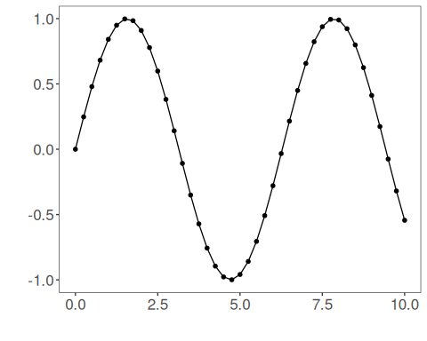
We now preserve the time order, split the data into train and test partitions, and project the windows into inputs and targets.
# Train-test split and projection (X, y)
samp <- ts_sample(ts, test_size = 5)
io_train <- ts_projection(samp$train)
io_test <- ts_projection(samp$test)
We now train the lstm model on the prepared training data.
# Training the LSTM model
model <- ts_lstm(ts_norm_gminmax(), input_size=4, epochs=10000)
set_example_seed()
model <- fit(model, x=io_train$input, y=io_train$output)
We first evaluate the in-sample fit so the model adjustment can be compared with the later forecast.
# Fit evaluation (train)
adjust <- predict(model, io_train$input)
adjust <- as.vector(adjust)
output <- as.vector(io_train$output)
ev_adjust <- evaluate(model, output, adjust)
ev_adjust$mse
## [1] 2.848104e-07
We now forecast the test set and compare the predicted values with the observed ones.
# Forecast on test set
steps_ahead <- 1
io_test <- ts_projection(samp$test)
prediction <- predict(model, x=io_test$input, steps_ahead=steps_ahead)
prediction <- as.vector(prediction)
output <- as.vector(io_test$output)
if (steps_ahead > 1)
output <- output[1:steps_ahead]
print(sprintf("%.2f, %.2f", output, prediction))
## [1] "0.41, 0.41" "0.17, 0.17" "-0.08, -0.07" "-0.32, -0.32" "-0.54, -0.54"
This chunk evaluates the custom component on the held-out test segment.
# Test evaluation
ev_test <- evaluate(model, output, prediction)
print(head(ev_test$metrics))
## mse smape R2
## 1 3.1148e-07 0.001647136 0.9999973
print(sprintf("smape: %.2f", 100*ev_test$metrics$smape))
## [1] "smape: 0.16"
This final plot summarizes the result of the transformation so the effect can be interpreted visually.
# Plot results
yvalues <- c(io_train$output, io_test$output)
plot_ts_pred(y=yvalues, yadj=adjust, ypre=prediction, color_prediction=if (steps_ahead == 1) "green" else "orange") + theme(text = element_text(size=16))
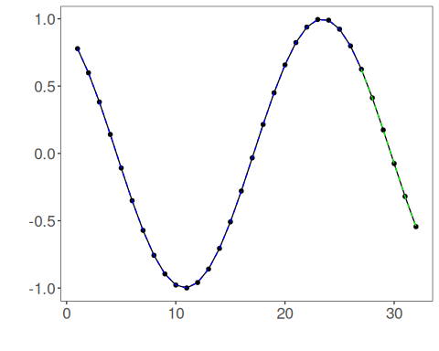
References - S. Hochreiter and J. Schmidhuber (1997). Long short-term memory. Neural Computation, 9(8), 1735–1780.

