Build ts_data
About the technique - ts_data() converts a raw time series into the tabular representation used by tspredit. - Each row stores one forecasting context and the lag columns (t{k}) define what the model can observe before predicting the next value.
Didactic goal: understand the internal representation that later projection, preprocessing, and prediction examples rely on.
source(url("https://raw.githubusercontent.com/cefet-rj-dal/tspredit/main/examples/seed.R"))
#install.packages("tspredit")
# Loading the package
library(tspredit)
We load the example data and separate the variables that will be used in the following steps.
# Load data and split axis/value
data(tsd)
x <- tsd$x
y <- tsd$y
We plot the data here so the effect of the next transformation can be compared visually.
library(ggplot2)
# Visualize the original series
plot_ts(x = x, y = y) + theme(text = element_text(size=16))
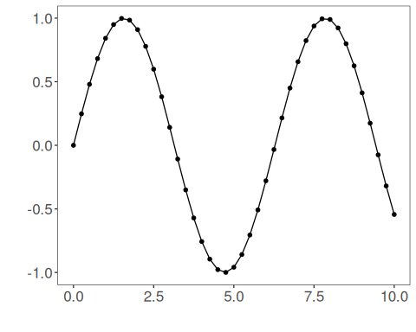
We first build ts_data without a sliding window so the base structure is easier to inspect.
# ts_data without window (only t0)
data <- ts_data(y)
ts_head(data)
## t0
## [1,] 0.0000000
## [2,] 0.2474040
## [3,] 0.4794255
## [4,] 0.6816388
## [5,] 0.8414710
## [6,] 0.9489846
plot_ts(y=data[,1]) + theme(text = element_text(size=16))
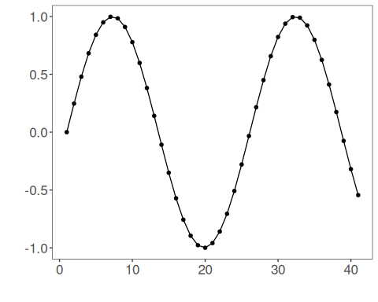
We now rebuild the same series with a sliding window of size 10 so each row stores recent lags explicitly.
# ts_data with window size 10 (t9..t0)
data10 <- ts_data(y, 10)
ts_head(data10)
## t9 t8 t7 t6 t5 t4 t3 t2 t1 t0
## [1,] 0.0000000 0.2474040 0.4794255 0.6816388 0.8414710 0.9489846 0.9974950 0.9839859 0.9092974 0.7780732
## [2,] 0.2474040 0.4794255 0.6816388 0.8414710 0.9489846 0.9974950 0.9839859 0.9092974 0.7780732 0.5984721
## [3,] 0.4794255 0.6816388 0.8414710 0.9489846 0.9974950 0.9839859 0.9092974 0.7780732 0.5984721 0.3816610
## [4,] 0.6816388 0.8414710 0.9489846 0.9974950 0.9839859 0.9092974 0.7780732 0.5984721 0.3816610 0.1411200
## [5,] 0.8414710 0.9489846 0.9974950 0.9839859 0.9092974 0.7780732 0.5984721 0.3816610 0.1411200 -0.1081951
## [6,] 0.9489846 0.9974950 0.9839859 0.9092974 0.7780732 0.5984721 0.3816610 0.1411200 -0.1081951 -0.3507832
This indexing example select a row, so you can inspect the structure returned by ts_data.
# Select a row
r1 <- data10[12,]
r1
## t9 t8 t7 t6 t5 t4 t3 t2 t1 t0
## [1,] 0.381661 0.14112 -0.1081951 -0.3507832 -0.5715613 -0.7568025 -0.8949894 -0.9775301 -0.9992928 -0.9589243
## attr(,"class")
## [1] "ts_data" "matrix" "array"
## attr(,"sw")
## [1] 10
This indexing example select a range of rows, so you can inspect the structure returned by ts_data.
# Select a range of rows
r2 <- data10[12:13,]
r2
## t9 t8 t7 t6 t5 t4 t3 t2 t1 t0
## [1,] 0.381661 0.1411200 -0.1081951 -0.3507832 -0.5715613 -0.7568025 -0.8949894 -0.9775301 -0.9992928 -0.9589243
## [2,] 0.141120 -0.1081951 -0.3507832 -0.5715613 -0.7568025 -0.8949894 -0.9775301 -0.9992928 -0.9589243 -0.8589345
## attr(,"class")
## [1] "ts_data" "matrix" "array"
## attr(,"sw")
## [1] 10
This indexing example select a column, so you can inspect the structure returned by ts_data.
# Select a column
c1 <- data10[,1]
ts_head(c1)
## t9
## [1,] 0.0000000
## [2,] 0.2474040
## [3,] 0.4794255
## [4,] 0.6816388
## [5,] 0.8414710
## [6,] 0.9489846
This indexing example select a range of columns, so you can inspect the structure returned by ts_data.
# Select a range of columns
c2 <- data10[,1:2]
ts_head(c2)
## t9 t8
## [1,] 0.0000000 0.2474040
## [2,] 0.2474040 0.4794255
## [3,] 0.4794255 0.6816388
## [4,] 0.6816388 0.8414710
## [5,] 0.8414710 0.9489846
## [6,] 0.9489846 0.9974950
This indexing example select a range of rows and columns, so you can inspect the structure returned by ts_data.
# Select a range of rows and columns
rc1 <- data10[12:13,1:2]
rc1
## t9 t8
## [1,] 0.381661 0.1411200
## [2,] 0.141120 -0.1081951
## attr(,"class")
## [1] "ts_data" "matrix" "array"
## attr(,"sw")
## [1] 2
This indexing example select one row and a range of columns, so you can inspect the structure returned by ts_data.
# Select one row and a range of columns
rc2 <- data10[12,1:2]
rc2
## t9 t8
## [1,] 0.381661 0.14112
## attr(,"class")
## [1] "ts_data" "matrix" "array"
## attr(,"sw")
## [1] 2
This indexing example select a range of rows and one column, so you can inspect the structure returned by ts_data.
# Select a range of rows and one column
rc3 <- data10[12:13,1]
rc3
## t9
## [1,] 0.381661
## [2,] 0.141120
## attr(,"class")
## [1] "ts_data" "matrix" "array"
## attr(,"sw")
## [1] 1
This indexing example select a single observation, so you can inspect the structure returned by ts_data.
# Select a single observation
rc4 <- data10[12,1]
rc4
## t9
## [1,] 0.381661
## attr(,"class")
## [1] "ts_data" "matrix" "array"
## attr(,"sw")
## [1] 1

