Project ts_data into X and y
About the technique - ts_projection() separates the lagged attributes from the forecast target. - This is the bridge between the time-series representation and the supervised-learning interface expected by forecasting models.
Didactic goal: see exactly how a time-series window becomes model input (X) and expected output (y).
source(url("https://raw.githubusercontent.com/cefet-rj-dal/tspredit/main/examples/seed.R"))
#install.packages("tspredit")
# Loading the package
library(tspredit)
We load the example series that will be used throughout the demonstration.
# Series for study
data(tsd)
Before moving on, we visualize the series so the effect of the next transformation can be compared against the original signal.
# Series visualization
library(ggplot2)
plot_ts(x=tsd$x, y=tsd$y) + theme(text = element_text(size=16))
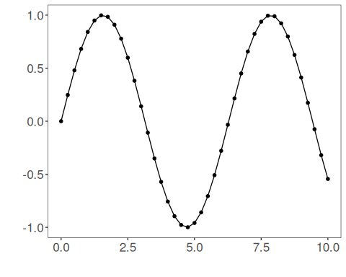
The next step organizes the series into sliding windows, which is the tabular representation used by the later transformations and models.
# Sliding windows
sw_size <- 5
ts <- ts_data(tsd$y, sw_size)
ts_head(ts, 3)
## t4 t3 t2 t1 t0
## [1,] 0.0000000 0.2474040 0.4794255 0.6816388 0.8414710
## [2,] 0.2474040 0.4794255 0.6816388 0.8414710 0.9489846
## [3,] 0.4794255 0.6816388 0.8414710 0.9489846 0.9974950
We now preserve the time order, split the data into train and test partitions, and project the windows into inputs and targets.
# Projection (X, y)
io <- ts_projection(ts)
This chunk input data (x).
# Input data (X)
ts_head(io$input)
## t4 t3 t2 t1
## [1,] 0.0000000 0.2474040 0.4794255 0.6816388
## [2,] 0.2474040 0.4794255 0.6816388 0.8414710
## [3,] 0.4794255 0.6816388 0.8414710 0.9489846
## [4,] 0.6816388 0.8414710 0.9489846 0.9974950
## [5,] 0.8414710 0.9489846 0.9974950 0.9839859
## [6,] 0.9489846 0.9974950 0.9839859 0.9092974
This chunk output data (y).
# Output data (y)
ts_head(io$output)
## t0
## [1,] 0.8414710
## [2,] 0.9489846
## [3,] 0.9974950
## [4,] 0.9839859
## [5,] 0.9092974
## [6,] 0.7780732

