Time-Ordered Train/Test Split
About the technique - ts_sample() creates training and test segments without shuffling the series. - In forecasting, preserving chronology is essential because the model must learn from the past and be evaluated on future observations only.
Didactic goal: understand how tspredit defines a valid forecasting split before any model is fitted.
source(url("https://raw.githubusercontent.com/cefet-rj-dal/tspredit/main/examples/seed.R"))
#install.packages("tspredit")
# Loading the package
library(tspredit)
We load the example series that will be used throughout the demonstration.
# Series for study
data(tsd)
We plot the data here so the effect of the next transformation can be compared visually.
library(ggplot2)
plot_ts(x = tsd$x, y = tsd$y) + theme(text = element_text(size=16))
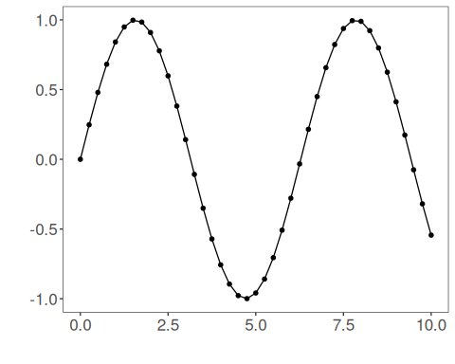
The next step organizes the series into sliding windows, which is the tabular representation used by the later transformations and models.
# Sliding windows
sw_size <- 10
ts <- ts_data(tsd$y, sw_size)
ts_head(ts, 3)
## t9 t8 t7 t6 t5 t4 t3 t2 t1 t0
## [1,] 0.0000000 0.2474040 0.4794255 0.6816388 0.8414710 0.9489846 0.9974950 0.9839859 0.9092974 0.7780732
## [2,] 0.2474040 0.4794255 0.6816388 0.8414710 0.9489846 0.9974950 0.9839859 0.9092974 0.7780732 0.5984721
## [3,] 0.4794255 0.6816388 0.8414710 0.9489846 0.9974950 0.9839859 0.9092974 0.7780732 0.5984721 0.3816610
This chunk sampling (train and test).
# Sampling (train and test)
test_size <- 3
samp <- ts_sample(ts, test_size)
This chunk first five rows of the train set.
# First five rows of the train set
ts_head(samp$train, 5)
## t9 t8 t7 t6 t5 t4 t3 t2 t1 t0
## [1,] 0.0000000 0.2474040 0.4794255 0.6816388 0.8414710 0.9489846 0.9974950 0.9839859 0.9092974 0.7780732
## [2,] 0.2474040 0.4794255 0.6816388 0.8414710 0.9489846 0.9974950 0.9839859 0.9092974 0.7780732 0.5984721
## [3,] 0.4794255 0.6816388 0.8414710 0.9489846 0.9974950 0.9839859 0.9092974 0.7780732 0.5984721 0.3816610
## [4,] 0.6816388 0.8414710 0.9489846 0.9974950 0.9839859 0.9092974 0.7780732 0.5984721 0.3816610 0.1411200
## [5,] 0.8414710 0.9489846 0.9974950 0.9839859 0.9092974 0.7780732 0.5984721 0.3816610 0.1411200 -0.1081951
This chunk last five rows of the train set.
# Last five rows of the train set
ts_head(samp$train[-c(1:(nrow(samp$train)-5)),])
## t9 t8 t7 t6 t5 t4 t3 t2 t1 t0
## [1,] -0.27941550 -0.03317922 0.2151200 0.4500441 0.6569866 0.8230809 0.9380000 0.9945988 0.9893582 0.9226042
## [2,] -0.03317922 0.21511999 0.4500441 0.6569866 0.8230809 0.9380000 0.9945988 0.9893582 0.9226042 0.7984871
## [3,] 0.21511999 0.45004407 0.6569866 0.8230809 0.9380000 0.9945988 0.9893582 0.9226042 0.7984871 0.6247240
## [4,] 0.45004407 0.65698660 0.8230809 0.9380000 0.9945988 0.9893582 0.9226042 0.7984871 0.6247240 0.4121185
## [5,] 0.65698660 0.82308088 0.9380000 0.9945988 0.9893582 0.9226042 0.7984871 0.6247240 0.4121185 0.1738895
This chunk test data.
# Test data
ts_head(samp$test)
## t9 t8 t7 t6 t5 t4 t3 t2 t1 t0
## [1,] 0.8230809 0.9380000 0.9945988 0.9893582 0.9226042 0.7984871 0.6247240 0.41211849 0.17388949 -0.07515112
## [2,] 0.9380000 0.9945988 0.9893582 0.9226042 0.7984871 0.6247240 0.4121185 0.17388949 -0.07515112 -0.31951919
## [3,] 0.9945988 0.9893582 0.9226042 0.7984871 0.6247240 0.4121185 0.1738895 -0.07515112 -0.31951919 -0.54402111

