Tutorial 04 - Baseline MLP Pipeline
After learning the forecasting protocols with ARIMA, we now move to a machine-learning pipeline.
Unlike ARIMA, an MLP consumes lagged inputs arranged as sliding windows. This tutorial introduces that representation and builds the baseline neural workflow that the next tutorials will progressively enrich.

Goal
Train a baseline MLP model with sliding windows and global min-max normalization.
source(url("https://raw.githubusercontent.com/cefet-rj-dal/tspredit/main/examples/seed.R"))
# Load packages and example series.
library(daltoolbox)
library(tspredit)
library(ggplot2)
set_example_seed(123L)
data(tsd)
We begin by plotting the original series, because every later transformation will still be derived from this same signal.
# Inspect the original series.
plot_ts(x = tsd$x, y = tsd$y) + theme(text = element_text(size = 16))
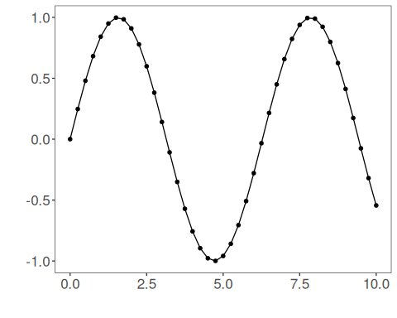
For the MLP, we first transform the time series into overlapping windows. Each row stores the recent past that will be used to predict the next value.
# Create sliding windows with 10 lagged values per row.
sw_size <- 10
ts <- ts_data(tsd$y, sw_size)
ts_head(ts, 3)
## t9 t8 t7 t6 t5 t4 t3 t2 t1 t0
## [1,] 0.0000000 0.2474040 0.4794255 0.6816388 0.8414710 0.9489846 0.9974950 0.9839859 0.9092974 0.7780732
## [2,] 0.2474040 0.4794255 0.6816388 0.8414710 0.9489846 0.9974950 0.9839859 0.9092974 0.7780732 0.5984721
## [3,] 0.4794255 0.6816388 0.8414710 0.9489846 0.9974950 0.9839859 0.9092974 0.7780732 0.5984721 0.3816610
We now create a train/test split that preserves time order, then project the windowed data into input and output components.
# Split the windows in time order and project them into X and y.
samp <- ts_sample(ts, test_size = 5)
io_train <- ts_projection(samp$train)
io_test <- ts_projection(samp$test)
Before training the network, we define the normalization strategy. Here we use global min-max scaling, which is the most common starting point for neural models in this package.
# Define the preprocessing object used by the model.
preproc <- ts_norm_gminmax()
preproc
## $outliers
## $alpha
## [1] 1.5
##
## attr(,"class")
## [1] "outliers_boxplot" "dal_transform" "dal_base"
##
## attr(,"class")
## [1] "ts_norm_gminmax" "dal_transform" "dal_base"
Now we create the MLP itself. The argument input_size = 4 tells the model to use the four most recent lags from each window.
# Configure and fit the baseline MLP model.
model <- ts_mlp(
preprocess = ts_norm_gminmax(),
input_size = 4,
size = 4,
decay = 0,
maxit = 1000
)
set_example_seed()
model <- fit(model, x = io_train$input, y = io_train$output)
Before forecasting the test block, we inspect the in-sample fit on the training data.
# Evaluate the fitted values on the training portion.
adjust <- predict(model, io_train$input)
adjust <- as.vector(adjust)
ev_adjust <- evaluate(model, as.vector(io_train$output), adjust)
ev_adjust$metrics
## mse smape R2
## 1 1.432577e-05 0.008313728 0.9999712
The evaluation helper reports the same three metrics used throughout the tutorials:
- mse: mean squared error;
- smape: symmetric mean absolute percentage error;
- R2: coefficient of determination relative to the mean baseline.
The most important reading rule for R2 is simple: values closer to 1 are better, 0 means “equivalent to predicting the mean”, and values below 0 mean the model is worse than that constant baseline.
We now forecast the next five values from the first test window, using recursive prediction.
# Forecast the five-point test horizon.
prediction <- predict(model, x = io_test$input[1:1, ], steps_ahead = 5)
prediction <- as.vector(prediction)
output <- as.vector(io_test$output)
ev_test <- evaluate(model, output, prediction)
ev_test
## $values
## [1] 0.41211849 0.17388949 -0.07515112 -0.31951919 -0.54402111
##
## $prediction
## [1] 0.41787725 0.18362848 -0.06273766 -0.30699150 -0.53616730
##
## $smape
## [1] 0.06058831
##
## $mse
## [1] 0.0001001462
##
## $R2
## [1] 0.999135
##
## $metrics
## mse smape R2
## 1 0.0001001462 0.06058831 0.999135
The final plot shows the observed series, the training adjustment, and the forecasted test horizon.
# Plot the baseline MLP fit and forecast.
yvalues <- c(io_train$output, io_test$output)
plot_ts_pred(y = yvalues, yadj = adjust, ypre = prediction, color_prediction = "orange") +
theme(text = element_text(size = 16))
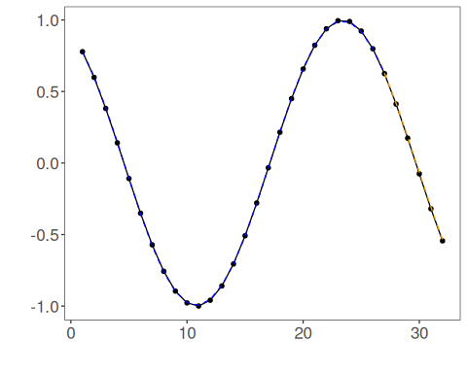

Interpretation
This is the baseline machine-learning pipeline that the next tutorials will evolve:
- create sliding windows;
- split train and test in time order;
- normalize the inputs;
- fit the model;
- forecast and evaluate.

