Tutorial 07 - MLP with Data Augmentation
Augmentation is useful when we want the model to learn from a richer set of training windows without touching the future test segment.
In this tutorial, we augment the training data only, then fit the same MLP forecasting pipeline.

Goal
Use ts_aug_jitter() to enlarge the training set before fitting the MLP model.
source(url("https://raw.githubusercontent.com/cefet-rj-dal/tspredit/main/examples/seed.R"))
# Load packages and example data.
library(daltoolbox)
library(tspredit)
library(ggplot2)
set_example_seed(123L)
data(tsd)
We start by creating the baseline sliding-window dataset.
# Build sliding windows from the original series.
ts <- ts_data(tsd$y, 10)
samp <- ts_sample(ts, test_size = 5)
Before augmenting anything, we separate the train and test windows. This is important because augmentation should affect training only.
# Split the data in time order before augmentation.
train_ts <- samp$train
test_ts <- samp$test
io_train <- ts_projection(train_ts)
io_test <- ts_projection(test_ts)
The augmentation operator works on the windowed dataset. We fit it on the training windows and then transform only the training portion.
# Augment the training windows with jitter.
augment_model <- ts_aug_jitter()
set_example_seed()
augment_model <- fit(augment_model, train_ts)
train_aug <- transform(augment_model, train_ts)
train_aug <- adjust_ts_data(train_aug)
io_train_aug <- ts_projection(train_aug)
The next lines show how much the training set grew after augmentation.
# Compare the original and augmented training sizes.
data.frame(
original_train_rows = nrow(train_ts),
augmented_train_rows = nrow(train_aug)
)
## original_train_rows augmented_train_rows
## 1 27 54
Now we fit the MLP using the augmented training windows.
# Fit the MLP on the augmented training set.
model <- ts_mlp(
preprocess = ts_norm_gminmax(),
input_size = 4,
size = 4,
decay = 0,
maxit = 1000
)
set_example_seed()
model <- fit(model, x = io_train_aug$input, y = io_train_aug$output)
We evaluate the resulting model on the untouched future test horizon.
# Forecast the test block without augmenting test data.
prediction <- as.vector(predict(model, x = io_test$input[1:1, ], steps_ahead = 5))
output <- as.vector(io_test$output)
ev_test <- evaluate(model, output, prediction)
ev_test
## $values
## [1] 0.41211849 0.17388949 -0.07515112 -0.31951919 -0.54402111
##
## $prediction
## [1] 0.6191626 0.5922642 0.5642638 0.6341227 0.6769353
##
## $smape
## [1] 1.498734
##
## $mse
## [1] 0.6053847
##
## $R2
## [1] -4.228739
##
## $metrics
## mse smape R2
## 1 0.6053847 1.498734 -4.228739
To better understand the result, it is helpful to compare the forecast values directly.
# Inspect the forecasted test horizon.
data.frame(
step = 1:5,
observed = output,
predicted = prediction
)
## step observed predicted
## 1 1 0.41211849 0.6191626
## 2 2 0.17388949 0.5922642
## 3 3 -0.07515112 0.5642638
## 4 4 -0.31951919 0.6341227
## 5 5 -0.54402111 0.6769353
We finish with a plot of the fitted values on the original training horizon and the forecast trajectory over the untouched test block.
# Plot the fit on the original train horizon and the forecast on test.
adjust <- as.vector(predict(model, io_train$input))
yvalues <- c(io_train$output, io_test$output)
plot_ts_pred(y = yvalues, yadj = adjust, ypre = prediction, color_prediction = "orange") +
theme(text = element_text(size = 16))
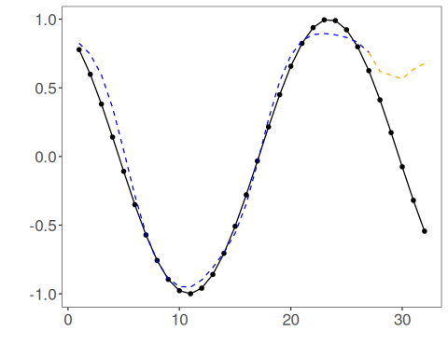

Interpretation
The key point in this tutorial is not the specific augmentation technique, but the pipeline logic:
- augment training windows only;
- keep the future horizon untouched;
- evaluate whether the extra diversity helps generalization.

