Tutorial 08 - Complete MLP Pipeline
At this point, we have explored the baseline MLP, normalization choices, filtering, and augmentation separately.
This tutorial combines those elements in a single end-to-end workflow so the reader can see how the pieces interact in practice.

Goal
Build an MLP pipeline with:
- filtering before window construction;
- augmentation on training windows only;
- adaptive normalization inside the model.
source(url("https://raw.githubusercontent.com/cefet-rj-dal/tspredit/main/examples/seed.R"))
# Load package and example data.
library(daltoolbox)
library(tspredit)
library(ggplot2)
set_example_seed(123L)
data(tsd)
The first stage is to filter the original series so that the supervised-learning windows are built from the transformed signal.
# Filter the original series before creating lag windows.
filter_model <- ts_fil_smooth()
set_example_seed()
filter_model <- fit(filter_model, tsd$y)
y_filtered <- transform(filter_model, tsd$y)
The next plot shows the original and filtered series together.
# Visualize the filtering effect before moving on.
plot_ts_pred(y = tsd$y, yadj = y_filtered) + theme(text = element_text(size = 16))
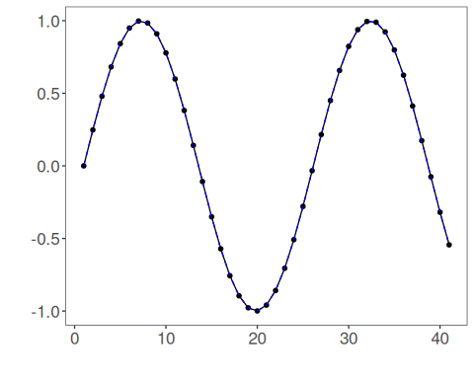
With the filtered series ready, we create sliding windows and split them in time order.
# Build windows and split the filtered series into train and test.
ts_filtered <- ts_data(y_filtered, 10)
samp <- ts_sample(ts_filtered, test_size = 5)
train_ts <- samp$train
test_ts <- samp$test
Before fitting the forecasting model, we augment the training windows only. This keeps the test horizon untouched while enriching the learning set.
# Apply augmentation only to the training windows.
augment_model <- ts_aug_jitter()
set_example_seed()
augment_model <- fit(augment_model, train_ts)
train_aug <- transform(augment_model, train_ts)
train_aug <- adjust_ts_data(train_aug)
io_train <- ts_projection(train_aug)
io_test <- ts_projection(test_ts)
Now we fit the MLP with adaptive normalization, so the model receives a richer and more flexible preprocessing pipeline.
# Fit the MLP with adaptive normalization on the augmented training windows.
model <- ts_mlp(
preprocess = ts_norm_an(),
input_size = 4,
size = 4,
decay = 0,
maxit = 1000
)
set_example_seed()
model <- fit(model, x = io_train$input, y = io_train$output)
We inspect the training adjustment first, then the out-of-sample forecast.
# Evaluate fit on the augmented training set.
adjust <- as.vector(predict(model, io_train$input))
ev_adjust <- evaluate(model, as.vector(io_train$output), adjust)
ev_adjust$metrics
## mse smape R2
## 1 0.008026988 0.177444 0.9838654
# Forecast the final test horizon with the complete pipeline.
prediction <- as.vector(predict(model, x = io_test$input[1:1, ], steps_ahead = 5))
output <- as.vector(io_test$output)
ev_test <- evaluate(model, output, prediction)
ev_test
## $values
## [1] 0.41211849 0.17388949 -0.07515112 -0.31951919 -0.54402111
##
## $prediction
## [1] 0.3773745 0.1228081 -0.1371693 -0.4047429 -0.6421997
##
## $smape
## [1] 0.2834829
##
## $mse
## [1] 0.004912963
##
## $R2
## [1] 0.9575665
##
## $metrics
## mse smape R2
## 1 0.004912963 0.2834829 0.9575665
A direct table makes it easier to inspect the five-step forecast.
# Compare observed and predicted values for the final horizon.
data.frame(
step = 1:5,
observed = output,
predicted = prediction
)
## step observed predicted
## 1 1 0.41211849 0.3773745
## 2 2 0.17388949 0.1228081
## 3 3 -0.07515112 -0.1371693
## 4 4 -0.31951919 -0.4047429
## 5 5 -0.54402111 -0.6421997
Finally, we plot the result of the complete workflow.
# Plot the fit and forecast produced by the complete MLP pipeline.
yvalues <- c(io_train$output, io_test$output)
plot_ts_pred(y = yvalues, yadj = adjust, ypre = prediction, color_prediction = "orange") +
theme(text = element_text(size = 16))
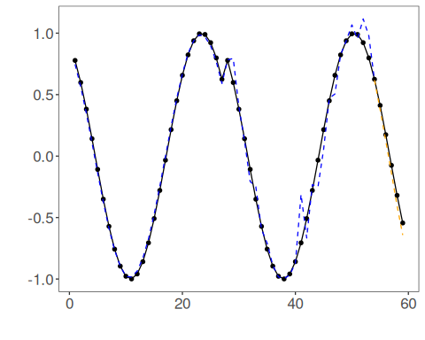

Interpretation
This is the first tutorial where the full pipeline logic becomes explicit:
- transform the signal before modeling;
- enlarge the training set;
- normalize inputs in a model-aware way;
- fit the regressor and forecast the future.
This is also a good point to ask whether the extra complexity is worth it. The next tutorial addresses that question by comparing model families directly.

