Objective: Build a ts_data object from a vector or data.frame and understand its sliding-window structure (columns t{k}).
#install.packages("tspredit")
# Loading the package
library(tspredit)
# Load data and split axis/value
data(tsd)
x <- tsd$x
y <- tsd$y
library(ggplot2)
# Visualize the original series
plot_ts(x = x, y = y) + theme(text = element_text(size=16))
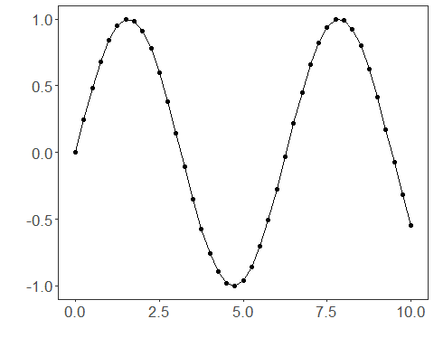
# ts_data without window (only t0)
data <- ts_data(y)
ts_head(data)
## t0
## [1,] 0.0000000
## [2,] 0.2474040
## [3,] 0.4794255
## [4,] 0.6816388
## [5,] 0.8414710
## [6,] 0.9489846
plot_ts(y=data[,1]) + theme(text = element_text(size=16))
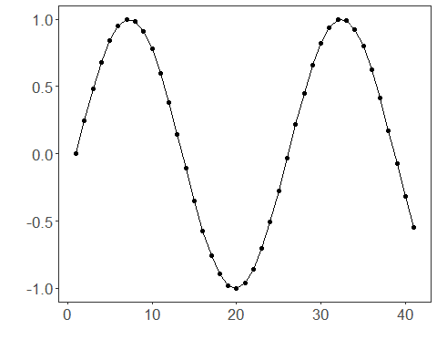
# ts_data with window size 10 (t9..t0)
data10 <- ts_data(y, 10)
ts_head(data10)
## t9 t8 t7 t6 t5 t4
## [1,] 0.0000000 0.2474040 0.4794255 0.6816388 0.8414710 0.9489846
## [2,] 0.2474040 0.4794255 0.6816388 0.8414710 0.9489846 0.9974950
## [3,] 0.4794255 0.6816388 0.8414710 0.9489846 0.9974950 0.9839859
## [4,] 0.6816388 0.8414710 0.9489846 0.9974950 0.9839859 0.9092974
## [5,] 0.8414710 0.9489846 0.9974950 0.9839859 0.9092974 0.7780732
## [6,] 0.9489846 0.9974950 0.9839859 0.9092974 0.7780732 0.5984721
## t3 t2 t1 t0
## [1,] 0.9974950 0.9839859 0.9092974 0.7780732
## [2,] 0.9839859 0.9092974 0.7780732 0.5984721
## [3,] 0.9092974 0.7780732 0.5984721 0.3816610
## [4,] 0.7780732 0.5984721 0.3816610 0.1411200
## [5,] 0.5984721 0.3816610 0.1411200 -0.1081951
## [6,] 0.3816610 0.1411200 -0.1081951 -0.3507832
# Select a row
r1 <- data10[12,]
r1
## t9 t8 t7 t6 t5 t4
## [1,] 0.381661 0.14112 -0.1081951 -0.3507832 -0.5715613 -0.7568025
## t3 t2 t1 t0
## [1,] -0.8949894 -0.9775301 -0.9992928 -0.9589243
## attr(,"class")
## [1] "ts_data" "matrix" "array"
## attr(,"sw")
## [1] 10
# Select a range of rows
r2 <- data10[12:13,]
r2
## t9 t8 t7 t6 t5
## [1,] 0.381661 0.1411200 -0.1081951 -0.3507832 -0.5715613
## [2,] 0.141120 -0.1081951 -0.3507832 -0.5715613 -0.7568025
## t4 t3 t2 t1 t0
## [1,] -0.7568025 -0.8949894 -0.9775301 -0.9992928 -0.9589243
## [2,] -0.8949894 -0.9775301 -0.9992928 -0.9589243 -0.8589345
## attr(,"class")
## [1] "ts_data" "matrix" "array"
## attr(,"sw")
## [1] 10
# Select a column
c1 <- data10[,1]
ts_head(c1)
## t9
## [1,] 0.0000000
## [2,] 0.2474040
## [3,] 0.4794255
## [4,] 0.6816388
## [5,] 0.8414710
## [6,] 0.9489846
# Select a range of columns
c2 <- data10[,1:2]
ts_head(c2)
## t9 t8
## [1,] 0.0000000 0.2474040
## [2,] 0.2474040 0.4794255
## [3,] 0.4794255 0.6816388
## [4,] 0.6816388 0.8414710
## [5,] 0.8414710 0.9489846
## [6,] 0.9489846 0.9974950
# Select a range of rows and columns
rc1 <- data10[12:13,1:2]
rc1
## t9 t8
## [1,] 0.381661 0.1411200
## [2,] 0.141120 -0.1081951
## attr(,"class")
## [1] "ts_data" "matrix" "array"
## attr(,"sw")
## [1] 2
# Select one row and a range of columns
rc2 <- data10[12,1:2]
rc2
## t9 t8
## [1,] 0.381661 0.14112
## attr(,"class")
## [1] "ts_data" "matrix" "array"
## attr(,"sw")
## [1] 2
# Select a range of rows and one column
rc3 <- data10[12:13,1]
rc3
## t9
## [1,] 0.381661
## [2,] 0.141120
## attr(,"class")
## [1] "ts_data" "matrix" "array"
## attr(,"sw")
## [1] 1
# Select a single observation
rc4 <- data10[12,1]
rc4
## t9
## [1,] 0.381661
## attr(,"class")
## [1] "ts_data" "matrix" "array"
## attr(,"sw")
## [1] 1

