ARIMA(p, d, q): ARIMA models represent a univariate time series as a combination of autoregressive (AR) terms, differencing for integration (I), and moving-average (MA) terms. An ARIMA(p, d, q) is built by: - differencing the series d times to achieve approximate stationarity; - modeling the differenced series with p autoregressive lags and q moving-average terms; - estimating parameters by maximum likelihood and selecting orders using an information criterion (e.g., AICc) and residual diagnostics.
In the example below, the function ts_arima() performs automatic order selection and fitting. Forecasts are generated recursively for the desired number of steps ahead.
Objective: Fit and evaluate an ARIMA (AutoRegressive Integrated Moving Average) model for time-series forecasting, performing a train-test split, automatic order selection, and evaluation with metrics and visualization.
#install.packages("tspredit")
# Loading the package
library(tspredit)
# Series for study (no sliding window)
data(tsd)
ts <- ts_data(tsd$y, 0)
ts_head(ts, 3)
## t0
## [1,] 0.0000000
## [2,] 0.2474040
## [3,] 0.4794255
# Series visualization
library(ggplot2)
plot_ts(x=tsd$x, y=tsd$y) + theme(text = element_text(size=16))
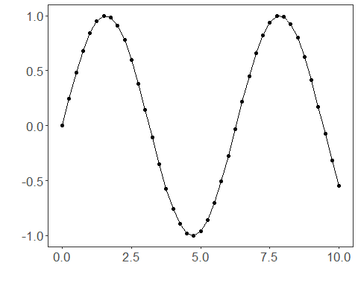
# Train-test split and projection (X, y)
samp <- ts_sample(ts, test_size = 5)
io_train <- ts_projection(samp$train)
io_test <- ts_projection(samp$test)
# Training the ARIMA model (orders selected automatically)
model <- ts_arima()
model <- fit(model, x=io_train$input, y=io_train$output)
# Fit evaluation (train)
adjust <- predict(model, io_train$input)
adjust <- as.vector(adjust)
output <- as.vector(io_train$output)
ev_adjust <- evaluate(model, output, adjust)
ev_adjust$mse
## [1] 0.02857686
# Forecast on test set (5 steps ahead)
prediction <- predict(model, x=io_test$input[1,], steps_ahead=5)
prediction <- as.vector(prediction)
output <- as.vector(io_test$output)
ev_test <- evaluate(model, output, prediction)
ev_test
## $values
## [1] 0.41211849 0.17388949 -0.07515112 -0.31951919 -0.54402111
##
## $prediction
## [1] 0.6011374 0.5784414 0.5566023 0.5355877 0.5153665
##
## $smape
## [1] 1.489711
##
## $mse
## [1] 0.4904025
##
## $R2
## [1] -3.235632
##
## $metrics
## mse smape R2
## 1 0.4904025 1.489711 -3.235632
# Plot comparing actual vs fit (train) and forecast (test)
yvalues <- c(io_train$output, io_test$output)
plot_ts_pred(y=yvalues, yadj=adjust, ypre=prediction) + theme(text = element_text(size=16))
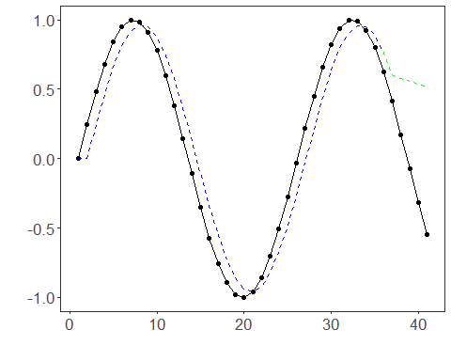
References - G. E. P. Box, G. M. Jenkins, G. C. Reinsel, and G. M. Ljung (2015). Time Series Analysis: Forecasting and Control. Wiley. - R. J. Hyndman and Y. Khandakar (2008). Automatic time series forecasting: The forecast package for R. Journal of Statistical Software, 27(3), 1–22. doi:10.18637/jss.v027.i03

