k-NN regression: k-NN regression predicts the next value by averaging (or weighting) the targets of the k most similar historical windows according to a distance measure (e.g., Euclidean). In the sliding-window setup, each row encodes the most recent lags of the series; neighbors with similar local patterns contribute to the forecast. The method is nonparametric and relies on appropriate scaling and a sensible choice of k.
Objective: Use KNN (K-Nearest Neighbors) to forecast time series from sliding windows, with normalization, model fitting, and evaluation.
# Time Series Regression - KNN
# Installing the package (if needed)
#install.packages("tspredit")
# Loading the packages
library(daltoolbox)
library(tspredit)
# Series for study and sliding windows
data(tsd)
ts <- ts_data(tsd$y, 10)
ts_head(ts, 3)
## t9 t8 t7 t6 t5 t4 t3 t2 t1 t0
## [1,] 0.0000000 0.2474040 0.4794255 0.6816388 0.8414710 0.9489846 0.9974950 0.9839859 0.9092974 0.7780732
## [2,] 0.2474040 0.4794255 0.6816388 0.8414710 0.9489846 0.9974950 0.9839859 0.9092974 0.7780732 0.5984721
## [3,] 0.4794255 0.6816388 0.8414710 0.9489846 0.9974950 0.9839859 0.9092974 0.7780732 0.5984721 0.3816610
# Series visualization
library(ggplot2)
plot_ts(x=tsd$x, y=tsd$y) + theme(text = element_text(size=16))
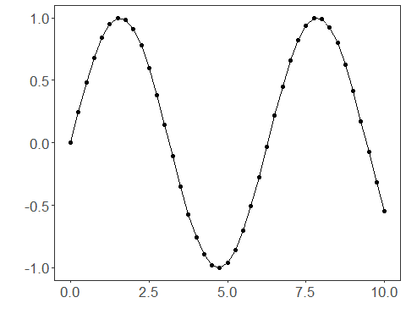
# Train-test split and projection (X, y)
samp <- ts_sample(ts, test_size = 5)
io_train <- ts_projection(samp$train)
io_test <- ts_projection(samp$test)
# Preprocessing (global min-max normalization)
preproc <- ts_norm_gminmax()
# Training the KNN model
model <- ts_knn(ts_norm_gminmax(), input_size=4, k=3)
model <- fit(model, x=io_train$input, y=io_train$output)
# Fit evaluation (train)
adjust <- predict(model, io_train$input)
adjust <- as.vector(adjust)
output <- as.vector(io_train$output)
ev_adjust <- evaluate(model, output, adjust)
ev_adjust$mse
## [1] 0.00169231
# Forecast on test set (5 steps ahead)
prediction <- predict(model, x=io_test$input[1,], steps_ahead=5)
prediction <- as.vector(prediction)
output <- as.vector(io_test$output)
ev_test <- evaluate(model, output, prediction)
ev_test
## $values
## [1] 0.41211849 0.17388949 -0.07515112 -0.31951919 -0.54402111
##
## $prediction
## [1] 0.5349524 0.3737510 0.1381953 -0.1059528 -0.3435132
##
## $smape
## [1] 0.8890066
##
## $mse
## [1] 0.0372727
##
## $R2
## [1] 0.6780737
##
## $metrics
## mse smape R2
## 1 0.0372727 0.8890066 0.6780737
# Plot comparing actual vs fit (train) and forecast (test)
yvalues <- c(io_train$output, io_test$output)
plot_ts_pred(y=yvalues, yadj=adjust, ypre=prediction) + theme(text = element_text(size=16))
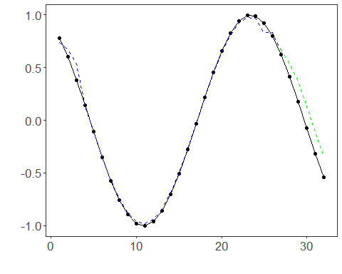
References - T. Cover and P. Hart (1967). Nearest neighbor pattern classification. IEEE Transactions on Information Theory, 13(1), 21–27.

