No filter: The identity filter simply forwards the input series without modification. It serves as a baseline to quantify the marginal effect of any smoothing step in a pipeline.
Objective: Show the identity filter pipeline (no change), useful to compare with other filters and validate the interface.
# Filter - none (identity)
# Installing the package (if needed)
#install.packages("tspredit")
# Loading the packages
library(daltoolbox)
library(tspredit)
# Series for study with artificial noise and spikes
data(tsd)
y <- tsd$y
noise <- rnorm(length(y), 0, sd(y)/10)
spike <- rnorm(1, 0, sd(y))
tsd$y <- tsd$y + noise
tsd$y[10] <- tsd$y[10] + spike
tsd$y[20] <- tsd$y[20] + spike
tsd$y[30] <- tsd$y[30] + spike
library(ggplot2)
# Noisy series visualization
plot_ts(x=tsd$x, y=tsd$y) + theme(text = element_text(size=16))
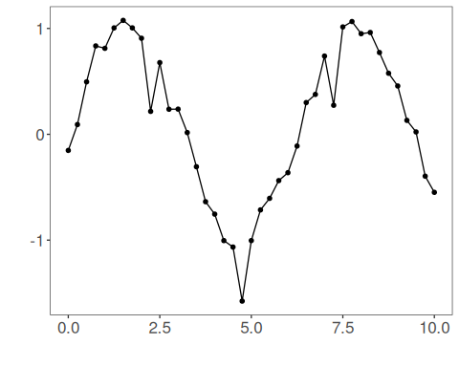
# Applying the identity filter
filter <- ts_fil_none()
filter <- fit(filter, tsd$y)
y <- transform(filter, tsd$y)
plot_ts_pred(y=tsd$y, yadj=y) + theme(text = element_text(size=16))
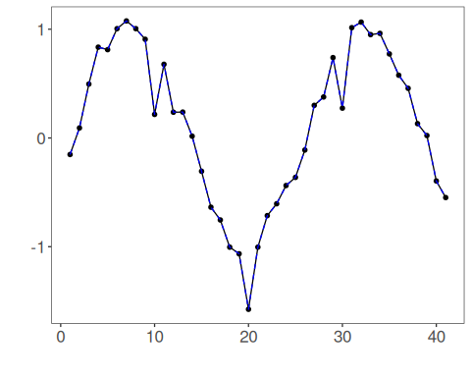
References - C. M. Bishop (2006). Pattern Recognition and Machine Learning. Springer.

