Seasonal adjustment filter: Seasonal adjustment estimates and removes recurring seasonal effects to produce a seasonally adjusted series. Common approaches include STL (Seasonal-Trend decomposition using Loess) and X‑13ARIMA‑SEATS. This example applies an STL‑based adjustment.
Objectives: Seasonal adjustment aims to remove periodic seasonal components from a series, making the underlying trend and cycle easier to analyze. After adjustment, remaining variation should reflect non-seasonal dynamics.
Notes: - Ensure the frequency/periodicity in your data is appropriate for seasonal estimation. - Seasonal adjustment methods can differ in how they model trend and irregular components.
# Filter - seasonal adjustment
# Install tspredit if needed
#install.packages("tspredit")
# Load packages
library(daltoolbox)
library(tspredit)
# Prepare a series (with added noise/spikes for illustration)
data(tsd)
y <- tsd$y
noise <- rnorm(length(y), 0, sd(y)/10)
spike <- rnorm(1, 0, sd(y))
tsd$y <- tsd$y + noise
tsd$y[10] <- tsd$y[10] + spike
tsd$y[20] <- tsd$y[20] + spike
tsd$y[30] <- tsd$y[30] + spike
library(ggplot2)
# Visualize original (noisy) series
plot_ts(x=tsd$x, y=tsd$y) + theme(text = element_text(size=16))
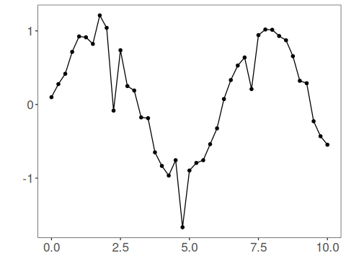
# Apply seasonal adjustment
filter <- ts_fil_seas_adj() # adjust for seasonal effects
filter <- fit(filter, tsd$y)
y <- transform(filter, tsd$y)
# Compare original vs seasonally adjusted
plot_ts_pred(y=tsd$y, yadj=y) + theme(text = element_text(size=16))
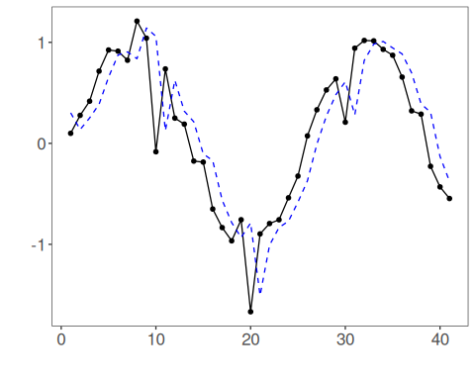
References - R. B. Cleveland, W. S. Cleveland, J. E. McRae, and I. Terpenning (1990). STL: A seasonal-trend decomposition procedure based on loess. Journal of Official Statistics, 6(1), 3–73.

