Adaptive normalization: AN centers and scales each window or time point using time‑varying statistics, typically computed via moving averages or exponentially weighted averages. This mitigates slow level/scale drift so models focus on local shape rather than absolute magnitude.
Objective: Apply adaptive normalization (moving average/EMA) to handle distribution shifts over time and observe the effect on the target.
# Exponential Adaptive Normalization
# Installing the package (if needed)
#install.packages("tspredit")
# Loading the packages
library(daltoolbox)
library(tspredit)
# Series for study
data(tsd)
# Series visualization
library(ggplot2)
plot_ts(x=tsd$x, y=tsd$y) + theme(text = element_text(size=16))
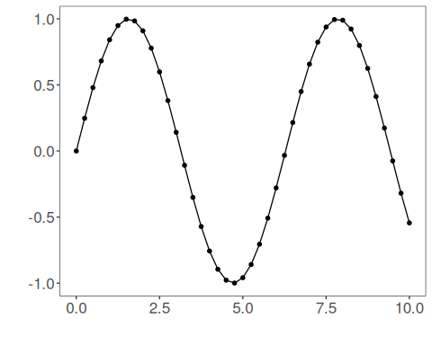
# Sliding windows
sw_size <- 10
ts <- ts_data(tsd$y, sw_size)
ts_head(ts, 3)
## t9 t8 t7 t6 t5 t4 t3 t2 t1 t0
## [1,] 0.0000000 0.2474040 0.4794255 0.6816388 0.8414710 0.9489846 0.9974950 0.9839859 0.9092974 0.7780732
## [2,] 0.2474040 0.4794255 0.6816388 0.8414710 0.9489846 0.9974950 0.9839859 0.9092974 0.7780732 0.5984721
## [3,] 0.4794255 0.6816388 0.8414710 0.9489846 0.9974950 0.9839859 0.9092974 0.7780732 0.5984721 0.3816610
summary(ts[,10])
## t0
## Min. :-0.99929
## 1st Qu.:-0.55091
## Median : 0.05397
## Mean : 0.02988
## 3rd Qu.: 0.63279
## Max. : 0.99460
# Target (t0) visualization after windowing
library(ggplot2)
plot_ts(y=ts[,10]) + theme(text = element_text(size=16))
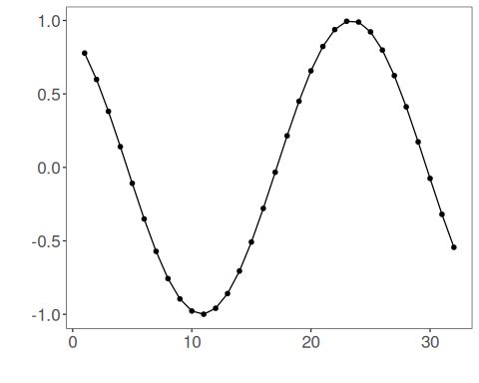
# Normalization
preproc <- ts_norm_an()
preproc <- fit(preproc, ts)
tst <- transform(preproc, ts)
ts_head(tst, 3)
## t9 t8 t7 t6 t5 t4 t3 t2 t1 t0
## [1,] 0.1770086 0.2931936 0.4021548 0.4971174 0.5721773 0.6226675 0.6454487 0.6391047 0.6040297 0.5424046
## [2,] 0.2650884 0.3740495 0.4690122 0.5440720 0.5945622 0.6173435 0.6109994 0.5759245 0.5142994 0.4299558
## [3,] 0.3677446 0.4627073 0.5377671 0.5882573 0.6110386 0.6046945 0.5696195 0.5079945 0.4236508 0.3218327
summary(tst[,10])
## t0
## Min. :0.04995
## 1st Qu.:0.15185
## Median :0.41183
## Mean :0.44854
## 3rd Qu.:0.73197
## Max. :0.94995
plot_ts(y=ts[1,]) + theme(text = element_text(size=16))
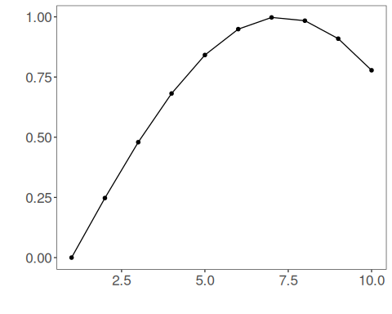
References - Ogasawara, E., Martinez, L. C., De Oliveira, D., Zimbrão, G., Pappa, G. L., Mattoso, M. (2010). Adaptive Normalization: A novel data normalization approach for non-stationary time series. Proceedings of the International Joint Conference on Neural Networks (IJCNN). doi:10.1109/IJCNN.2010.5596746

