Sliding window min-max normalization: For each sliding window (row), compute its local min and max and rescale that window to [0,1]. This emphasizes local shape and pattern while removing level and amplitude differences across windows.
Objective: Apply per-window min-max normalization (each row scaled by its own minima and maxima) and visualize the effect of scaling.
# Window-based Normalization (Min-Max)
# Installing the package (if needed)
#install.packages("tspredit")
# Loading the packages
library(daltoolbox)
library(tspredit)
# Series for study
data(tsd)
# Series visualization
library(ggplot2)
plot_ts(x=tsd$x, y=tsd$y) + theme(text = element_text(size=16))
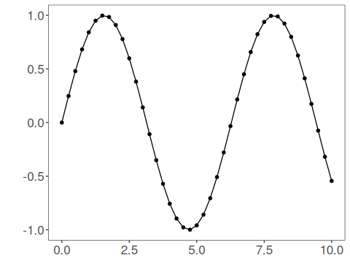
# Sliding windows
sw_size <- 10
ts <- ts_data(tsd$y, sw_size)
ts_head(ts, 3)
## t9 t8 t7 t6 t5 t4 t3 t2 t1 t0
## [1,] 0.0000000 0.2474040 0.4794255 0.6816388 0.8414710 0.9489846 0.9974950 0.9839859 0.9092974 0.7780732
## [2,] 0.2474040 0.4794255 0.6816388 0.8414710 0.9489846 0.9974950 0.9839859 0.9092974 0.7780732 0.5984721
## [3,] 0.4794255 0.6816388 0.8414710 0.9489846 0.9974950 0.9839859 0.9092974 0.7780732 0.5984721 0.3816610
summary(ts[,10])
## t0
## Min. :-0.99929
## 1st Qu.:-0.55091
## Median : 0.05397
## Mean : 0.02988
## 3rd Qu.: 0.63279
## Max. : 0.99460
# Target (t0) visualization after windowing
library(ggplot2)
plot_ts(y=ts[,10]) + theme(text = element_text(size=16))
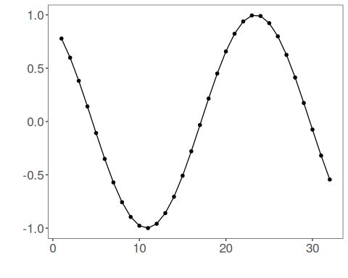
# Normalization (fit and transform)
preproc <- ts_norm_swminmax()
preproc <- fit(preproc, ts)
tst <- transform(preproc, ts)
ts_head(tst, 3)
## t9 t8 t7 t6 t5 t4 t3 t2 t1 t0
## [1,] 0.0000000 0.2480253 0.4806295 0.6833506 0.8435842 0.9513678 1.0000000 0.9864570 0.9115809 0.7800272
## [2,] 0.0000000 0.3093246 0.5789095 0.7919932 0.9353274 1.0000000 0.9819901 0.8824175 0.7074731 0.4680341
## [3,] 0.1587515 0.4871082 0.7466460 0.9212282 1.0000000 0.9780638 0.8567835 0.6436998 0.3520610 0.0000000
summary(tst[,10])
## t0
## Min. :0.0000
## 1st Qu.:0.0000
## Median :0.2264
## Mean :0.4301
## 3rd Qu.:0.9974
## Max. :1.0000
plot_ts(y=ts[1,]) + theme(text = element_text(size=16))
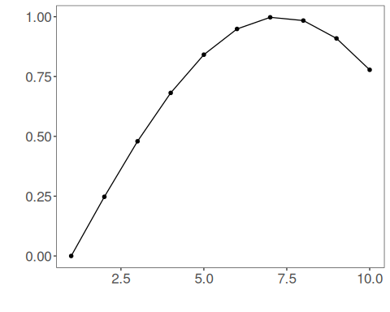
References - C. M. Bishop (2006). Pattern Recognition and Machine Learning. Springer.

