LSTM: Long Short-Term Memory (LSTM) networks are recurrent neural networks that incorporate gating mechanisms to mitigate vanishing/exploding gradients and capture long-range temporal dependencies. In a sliding-window setup, the sequence of lagged inputs is processed to output the next-step forecast. Key hyperparameters include the input window length, hidden size, and number of training epochs.
Objective: Train and evaluate an LSTM model for time-series forecasting with sliding windows, including normalization, fitting, and test evaluation.
# Time Series Regression - LSTM
# Installing packages (if needed)
#install.packages("tspredit")
# Loading the packages
library(daltoolbox)
library(daltoolboxdp)
library(tspredit)
# Series for study and sliding windows
data(tsd)
ts <- ts_data(tsd$y, 10)
ts_head(ts, 3)
## t9 t8 t7 t6 t5 t4 t3 t2 t1 t0
## [1,] 0.0000000 0.2474040 0.4794255 0.6816388 0.8414710 0.9489846 0.9974950 0.9839859 0.9092974 0.7780732
## [2,] 0.2474040 0.4794255 0.6816388 0.8414710 0.9489846 0.9974950 0.9839859 0.9092974 0.7780732 0.5984721
## [3,] 0.4794255 0.6816388 0.8414710 0.9489846 0.9974950 0.9839859 0.9092974 0.7780732 0.5984721 0.3816610
# Series visualization
library(ggplot2)
plot_ts(x=tsd$x, y=tsd$y) + theme(text = element_text(size=16))
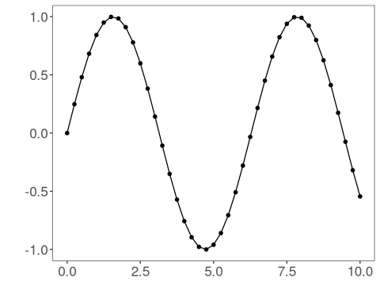
# Train-test split and projection (X, y)
samp <- ts_sample(ts, test_size = 5)
io_train <- ts_projection(samp$train)
io_test <- ts_projection(samp$test)
# Training the LSTM model
model <- ts_lstm(ts_norm_gminmax(), input_size=4, epochs=10000)
model <- fit(model, x=io_train$input, y=io_train$output)
# Fit evaluation (train)
adjust <- predict(model, io_train$input)
adjust <- as.vector(adjust)
output <- as.vector(io_train$output)
ev_adjust <- evaluate(model, output, adjust)
ev_adjust$mse
## [1] 0.0002777195
# Forecast on test set
steps_ahead <- 1
io_test <- ts_projection(samp$test)
prediction <- predict(model, x=io_test$input, steps_ahead=steps_ahead)
prediction <- as.vector(prediction)
output <- as.vector(io_test$output)
if (steps_ahead > 1)
output <- output[1:steps_ahead]
print(sprintf("%.2f, %.2f", output, prediction))
## [1] "0.41, 0.42" "0.17, 0.19" "-0.08, -0.07" "-0.32, -0.33" "-0.54, -0.56"
# Test evaluation
ev_test <- evaluate(model, output, prediction)
print(head(ev_test$metrics))
## mse smape R2
## 1 0.0001220179 0.04259129 0.9989461
print(sprintf("smape: %.2f", 100*ev_test$metrics$smape))
## [1] "smape: 4.26"
# Plot results
yvalues <- c(io_train$output, io_test$output)
plot_ts_pred(y=yvalues, yadj=adjust, ypre=prediction) + theme(text = element_text(size=16))
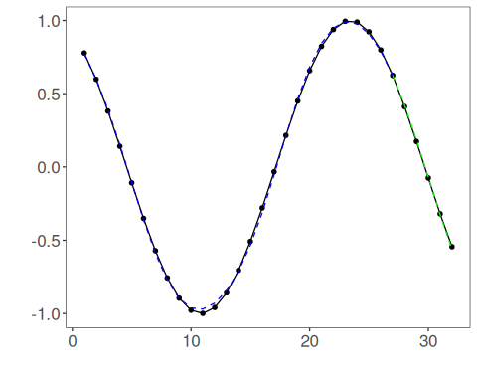
References - S. Hochreiter and J. Schmidhuber (1997). Long short-term memory. Neural Computation, 9(8), 1735–1780.

